Graph 1
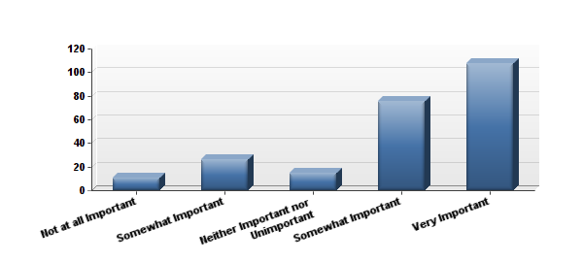

(Graph 1: Response by all participants to Question #1: “How important is it for government and
industry to reduce the practice of clearcut logging in the United States?”)

Graph 2

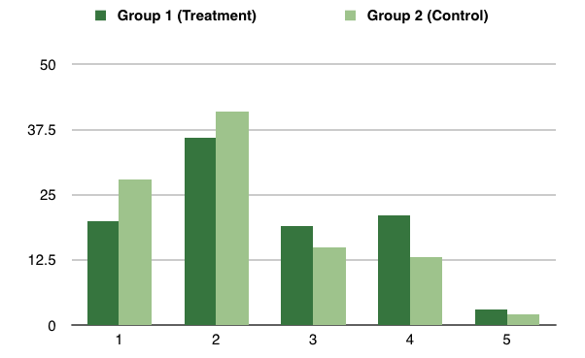
Graph 2: Are audiences more likely to learn about an organization’s central cause or issue – such as the
environmental issue of clearcut logging – through exposure to media coverage of controversial advertising?
(percentage basis; 0=least likely; 5=most likely)

Graph 3

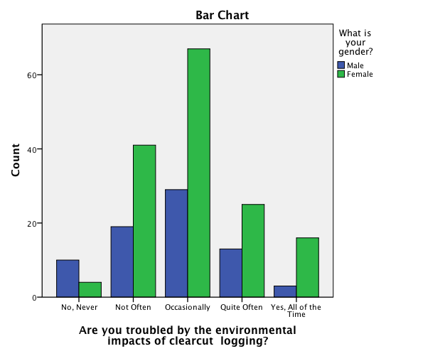

Graph 4

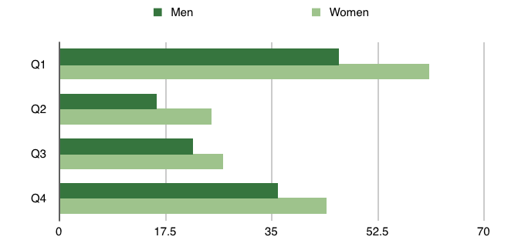
Graph 4: Is there a gender difference in the support of controversial environmental advertisements? (Treatment and control group totals of those responding favorably, on a percentage basis.) Q1. Are you likely or very likely to sign a petition for this cause? Q2. Are you likely to donate to an environmental group based on your concerns over clearcut logging? Q3. Are you troubled by the impacts of clearcut logging? Q4. Is this issue fairly represented by Oregon Wild’s advertisement?

