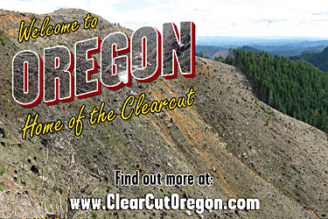
(Image 1: “Oregon, Home of the Clearcut” billboard advertisement produced by Oregon Wild and its partners.)

