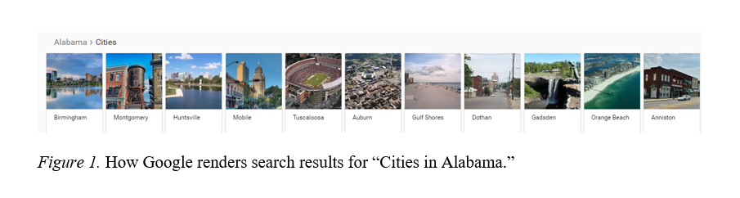

Appendix 1: List of 200 cities in study, in order of Google search rankings by state.
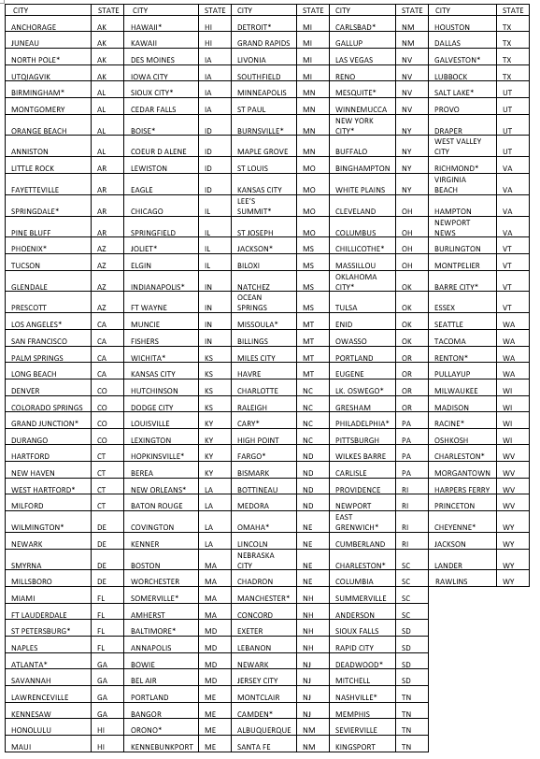
*Denotes city is also in sub-group of 50 for mobile and Facebook analysis.

