Searching for Citizen Engagement and City Hall:
200 Municipal Homepages in the United States and Their Rhetorical Outreach to Audiences
Jacqueline Johnson Lambiase, Ph.D.
Professor, Department of Strategic Communication
Texas Christian University

Abstract: U.S. cities rely on their websites to enhance citizen engagement, and digital government portals have been promoted for decades as gateways to participatory democracy. This study, through rhetorical and qualitative content analyses, focuses on 200 municipal homepages from 2017 and the ways they address audiences and invite participation. The findings reveal very few cities have: platforms for interactive discussions; representations of citizen activities; or ways to call citizens into being for the important work of shared governance.
Keywords: Citizen engagement, municipal communication, websites, audiences, digital townhall
Images on next pages: Figure 1 and Appendix 1

Author bio: Jacqueline Lambiase, Ph.D., serves as department chair and is a professor in the Department of Strategic Communication in the Bob Schieffer College of Communication at TCU. Her research focuses on public-sector communication, public relations ethics and case studies, and gendered media images. She is a co-director and founder of the Certified Public Communicator program at TCU, as well as a founder and organizer of the TCU Nonprofit Communicators Conference, now in its 10th year.

Contact information: P.O. Box 298065, Fort Worth, Texas 76129; j.lambiase@tcu.edu or 817.257.6552.

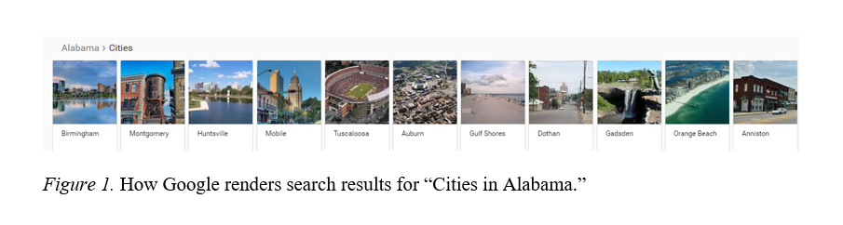

Appendix 1: List of 200 cities in study, in order of Google search rankings by state.
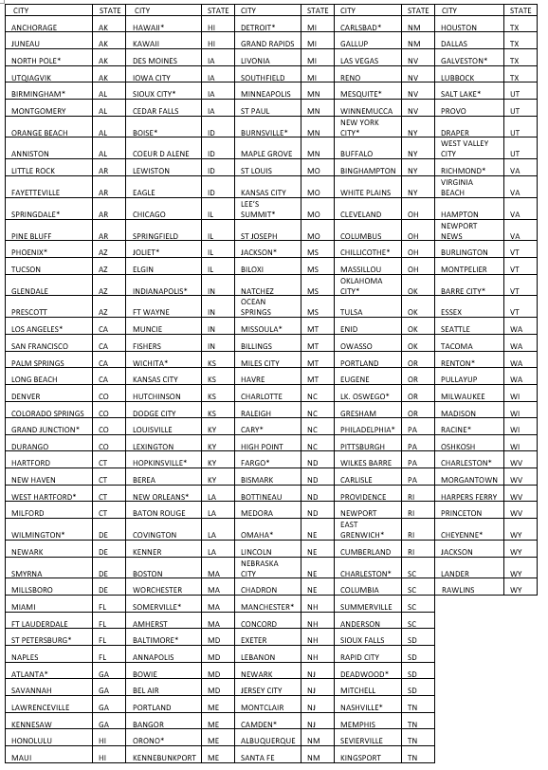
*Denotes city is also in sub-group of 50 for mobile and Facebook analysis.

