Author Bio

Jessie Spraggins Rochford is a doctoral student in the Art Education Department at Florida State University. She is also a practicing art therapist and mental health counselor at the Florida State University Counseling Center. Her research interests include collaborative practices between art therapists and art museum educators, and using the arts to support emotional wellness, develop empathy, and build resiliency.

Author Photo

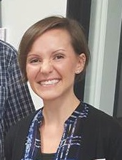

Key Terms:
art therapy, museum, museum education

