Running head: Aromatic plants volatiles regulated Aphis citricola infestation

Billing contact:
Yuncong Yao
College of Plant Science and Technology
Beijing University of Agriculture
Beijing, 102206, China.
Tel: +86-01-80799300
E-mail: yaoyc_20@126.com

Behavioral responses of Aphis citricola Van der Goot and its natural enemies Harmonia axyridis Pallas to non-host plant volatiles.

Song Beizhou^{1,2,#,} Liang Yinping^{1,#}, Liu Sizhou¹, Zhang Linfeng¹, Tang Guangbo¹, Ma Teng^{1,} Yao Yuncong^{1,2,*}
¹College of Plant Science and Technology, Beijing University of Agriculture, Beijing, 102206, China, E-mail: songbeizhou0821@163.com

² Beijing Collaborative Innovation Center for eco-envirenmental improvement with forestry and fruit trees, Beijing, 102206, China, E-mail: yaoyc_20@126.com

#Contributed equal to the work.

*Corresponding author; E-mail: yaoyc_20@126.com
Supplementary table 1

Tbale S1. Relative amount (% of internal standard peak area) of volatiles released by French marigold.
Retention time | Compounds | Relative amount (％)
2.72 | Pentanal | 1.22
3.28 | 1,6-Hexanediol | 1.76
4.19 | 2-Octene, (2E)-; | 1.52
4.49 | Hexanal | 4.76
4.82 | Hexamethylcyclotrisiloxane | 0.96
6.01 | Ethylbenzene | 0.90
6.27 | 3,5-Octadiyne | 2.10
6.94 | 1,2-xylene | 2.78
8.26 | alpha-Pinene | 2.18
9.05 | Hexanal, 2-ethyl-; | 2.25
10.15 | Octamethylcyclotetrasiloxane | 1.44
10.3 | 1,6,10-Dodecatriene,7,11-dimethyl-3-methylene-, (6Z) | 1.35
10.82 | 4-Methyl-1-(methylethyl)bicyclo[3.1.0]hexane | 1.22
11.5 | p-isopropyltoluene; | 3.59
11.78 | 2-Ethyl-1-hexanol | 25.90
11.98 | 1,3,6-Octatriene,3,7-dimethyl-, (3E)- | 3.40
13.89 | Benzene,1-methyl-4-(1-methylethenyl)- | 7.76
14.65 | Bicyclo[3.1.0]hex-2-ene,4-methylene-1-(1-methylethyl)- | 1.32
15.29 | (4E,6Z)-2,6-Dimethyl-2,4,6-oct​atriene | 2.01

Tbale S2. Relative amount (% of internal standard peak area) of volatiles released by savoty.
Retention time | Compounds | Relative amount (％)
4.2 | 2-Octene, (2E)-; | 1.20
4.48 | Hexanal | 2.62
5.92 | Leaf alcohol | 1.49
6.01 | Ethylbenzene | 8.04
6.27 | o-Xylene | 9.05
6.8 | 3-Heptanone | 1.26
6.93 | P-xylene | 7.60
9.03 | Hexanal, 2-ethyl- | 1.14
10.15 | Octamethyl cyclotetrasiloxane | 6.41
10.6 | 3-Octanol | 1.42
10.89 | 3-Hexen-1-ol,1-acetate, (3Z)- | 2.91
11.09 | 1,3-Dichlorobenzene | 1.86
11.76 | 2-Ethyl-1-hexanol | 23.29
11.96 | 1,3,6-Octatriene,3,7-dimethyl-(3E)-; | 4.12
14.49 | Nonyl aldehyde | 0.95
14.68 | Phenethyl alcohol | 2.59
15.28 | Cyclohexene,1,5,5-trimethyl-3-methylene- | 1.83
15.69 | Cyclopentasiloxane,2,2,4,4,6,6,8,8,10,10-decamethyl- | 1.16

Supplementary figure 1
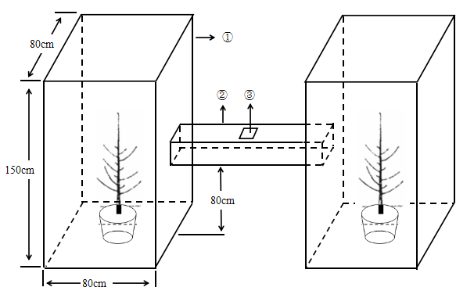
Figure S1. H-tube olfactometer schematic diagram. ①: Plastic boxes (80 cm in length, 80 cm in width, 150 cm in height); ②: Cross arm (20 cm in length, 8 cm in width, 8 cm in height); ③: Hole used to inoculate insects (5 cm in length, 5 cm in width).
Supplementary figure 2
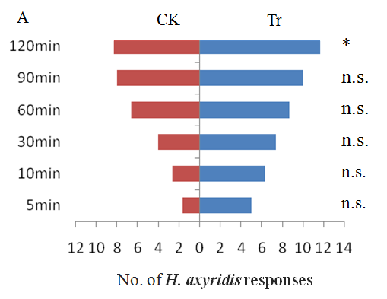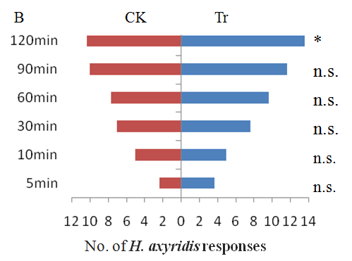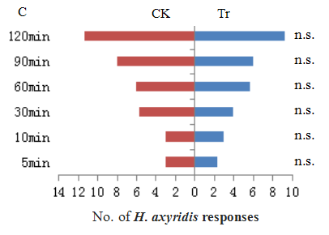
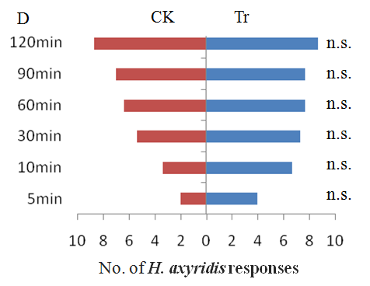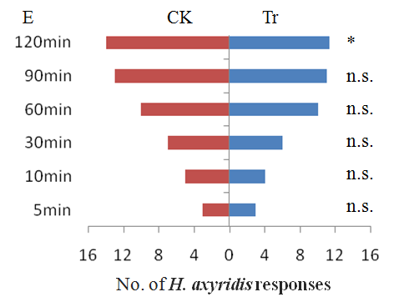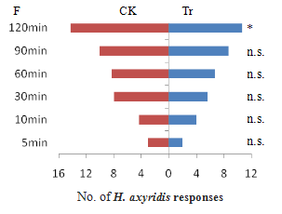

Figure S2. Response of Harmonia axyridis to French marigold (Tagetes patula L.) (A, B and C) and savory (Saturela hortensis L.) (D, E and F). A and D: no aphids, B and E: aphids present; C and F: aphids were applied for 2 hours and removed. Tr: apple trees + aromatic plants; CK: apple trees only. The different footnote symbols represent significant difference (t-test). * significant difference (P < 0.05). n.s. no significant difference.

Supplementary figure 3
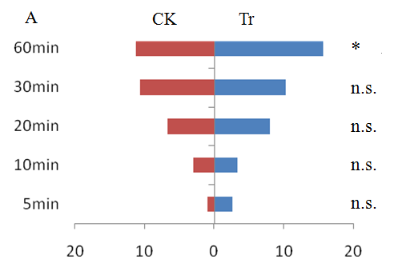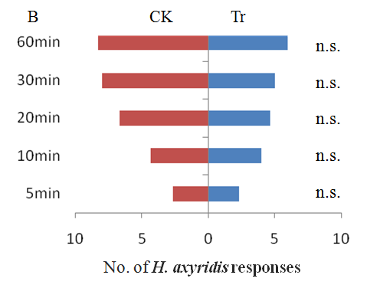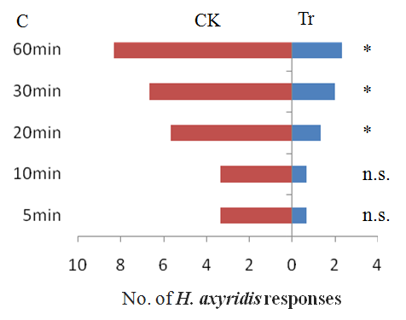
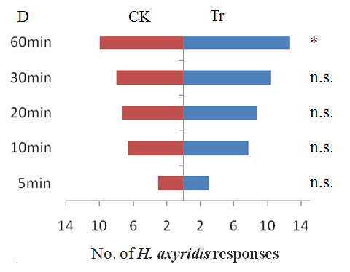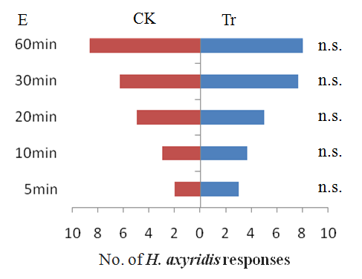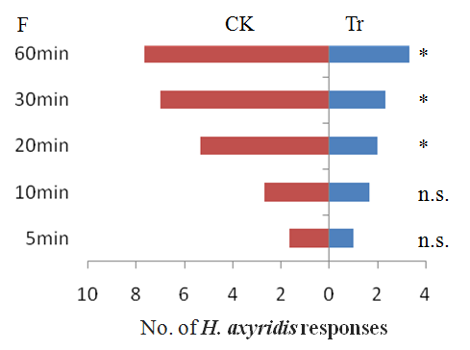
Figure S3. Response of Harmonia axyridis to 12.5μl/L (A, D), 25μl/L (B, E) and 50μl/L (C, F) D-limonene (A, B and C: no aphids; D, E and F: aphids present). Tr: apple tree + D-limonene; CK: apple tree + distilled water. The different footnote symbols represent significant difference (t-test). * significant difference (P < 0.05). n.s. no significant difference.

Supplementary figure 4
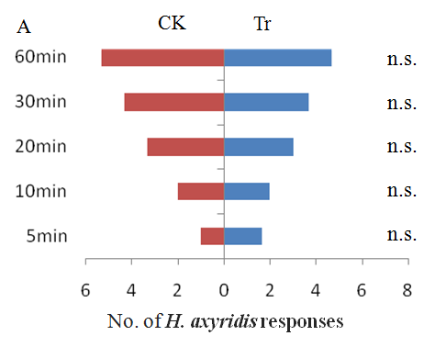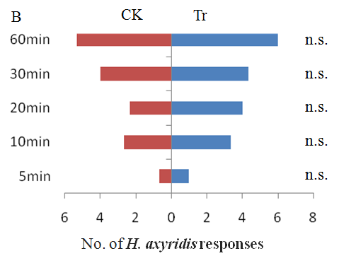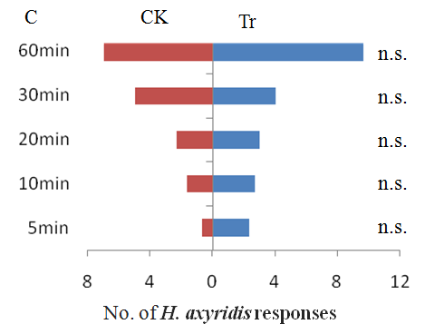
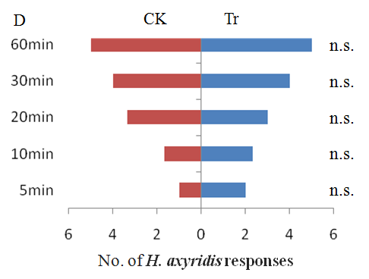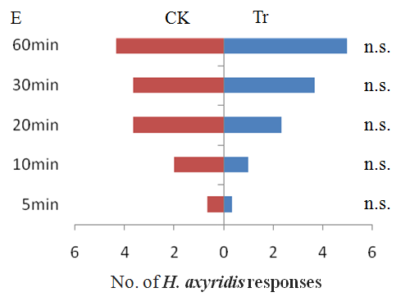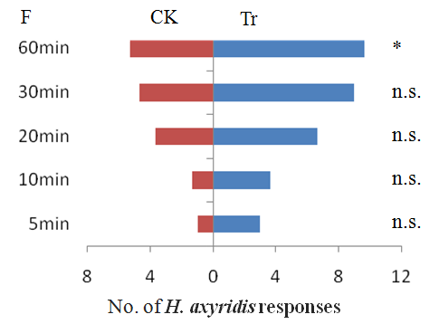
Figure S4. Response of Harmonia axyridis to 12.5μl/L (A, D), 25μl/L (B, E) and 50μl/L (C, F) terpinolen (A, B and C: no aphids; D, E and F: aphids present). Tr: apple tree + terpinolen; CK: apple tree + distilled water. The different footnote symbols represent significant difference (t-test). * significant difference (P < 0.05). n.s. no significant difference.

Supplementary figure 5
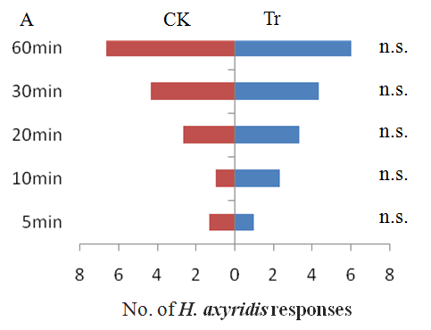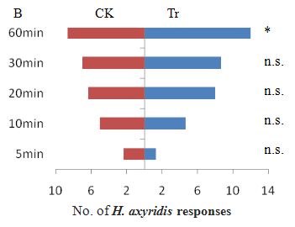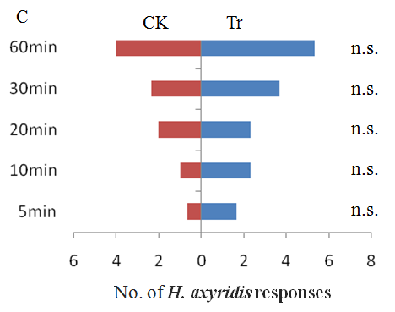
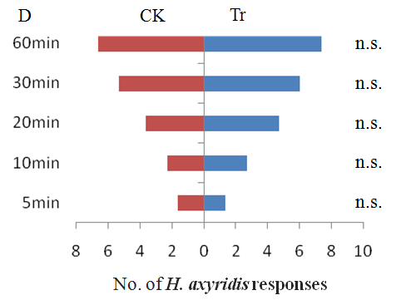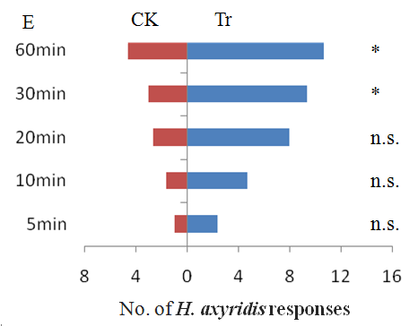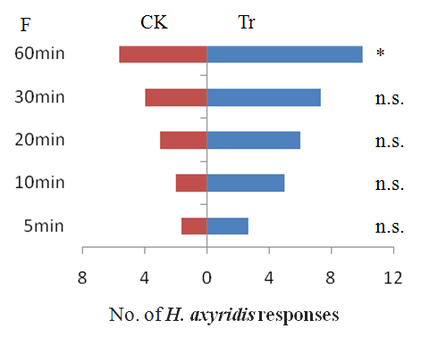
Figure S5. Response of Harmonia axyridis to 12.5μl/L (A, D), 25μl/L (B, E) and 50μl/L (C, F) 1:1 mixed D-limonene and terpinolen (A, B and C: no aphids; D, E and F: aphids present). Tr: apple tree + terpinolen; CK: apple tree + distilled water. The different footnote symbols represent significant difference (t-test). * significant difference (P < 0.05). n.s. no significant difference.

