Running title: A new subspecies of Pierella lena in northeastern Brazil

Please address correspondence to:
Márlon Paluch
Centro de Ciências Agrárias Ambientais e Biológicas
Universidade Federal do Recôncavo da Bahia
44.380-000, Cruz das Almas, Bahia, Brazil
Phone: +55 (75) 3621-9751
E-mail: marlonpaluch@gmail.com

A new subspecies of Pierella lena (Lepidoptera: Nymphalidae: Satyrinae) in northeastern Brazil

Márlon Paluch¹*, Thamara Zacca², Ricardo Russo Siewert², Olaf Hermann Hendrik Mielke² and Mirna Martins Casagrande²
¹Centro de Ciências Agrárias Ambientais e Biológicas, Universidade Federal do Recôncavo da Bahia, 44.380-000, Cruz das Almas, Bahia, Brazil

²Laboratório de Estudos de Lepidoptera Neotropical, Departamento de Zoologia, Universidade Federal do Paraná, P.O. Box 19.020, 81.531-980, Curitiba, Paraná, Brazil

*Corresponding author; E-mail: marlonpaluch@gmail.com
Abstract

Pierella lena atlantica Paluch, Zacca & Siewert ssp. nov. (Lepidoptera: Nymphalidae: Satyrinae) is described in the Atlantic Forest of Bahia (Itanagra, Una and Cachoeira), Brazil. A discussion about this new taxon, its relationship with the other subspecies of P. lena (Linnaeus, 1767), the first illustrations of the female genitalia, and an identification key to adults of Pierella hyalinus and Pierella lena in Brazil are provided.

Key Words: Haeterini; Neotropical region; Amazonian region; Atlantic Forest

Resumo

Pierella lena atlantica Paluch, Zacca & Siewert ssp. nov. (Lepidoptera: Nymphalidae: Satyrinae) é descrita da Mata Atlântica da Bahia (Itanagra, Una e Cachoeira). Uma discussão sobre o relacionamento deste táxon com as outras subespécies de P. lena (Linnaeus, 1767) é fornecida, a genitália feminina da espécie é ilustrada pela primeira vez, uma chave de identificação dos adultos de Pierella hyalinus e Pierella lena no Brasil é apresentada.

Palavras-Chave: Haeterini; Região Neotropical; Região Amazônica; Mata Atlântica

The Neotropical genus Pierella Westwood, 1851 is the most diverse within the tribe Haeterini (Nymphalidae: Satyrinae) and its distribution includes Central and South America (Constantino 1995, Lamas 2004). So far, 4 species of this genus have been reported in northeastern Brazil, and all are restricted to the Atlantic Forest: Pierella lamia (Sulzer, 1776) (“Pierella lamia” species group in revision by Zacca et al. [in press]) in Paraíba, Alagoas, Pernambuco and Bahia (Cardoso 1949; Kesselring & Ebert 1982; Zacca 2009; Zacca et al. 2011; Paluch et al. 2011), Pierella nereis (Drury, 1782) in Alagoas and Bahia (Cardoso 1949; Zacca et al. 2011), Pierella lena (Linnaeus, 1767) in Bahia (Zacca 2009) and Pierella hyalinus (Gmelin, [1790]) in north coastal Bahia (Paluch M, personal observations) Together, P. lena and P. hyalinus are easily recognized by their purple bluish hind wings. Pierella lena comprises 3 subspecies, P. lena lena (Linnaeus, 1767) on the plains of the lower Amazon River in Guyana, Suriname, French Guiana and Brazil; P. lena brasiliensis (C. Felder & R. Felder, 1862) in the upper Amazon River in Colombia, Peru, Ecuador and Brazil, and P. lena salma Constantino, 2007 known in Colombia, on the eastern slope of the Andes, in Putumayo and Caquetá, and also in northeastern Ecuador, in the upper Napo River (Lamas 2004; Salazar & Constantino 2007). This study provides a description of a new subspecies of P. lena in the northeastern region of Brazil, with illustrations of the female genitalia for the first time.

Materials and Methods ___

For the dissection of the genitalia of the studied specimens, their abdomens were detached and soaked in a heated test tube with 10% potassium hydroxide solution (KOH) for about 5 min. Illustrations were performed from images obtained in cellSens Imaging Software with the aid of a video camera SC30 Olympus attached to a stereoscopic microscope trinocular SZX7 Olympus. Full lines represent sclerotized structures; thin lines, membranous structures; and dashed lines, structures visible through transparency. Taxonomy follows Lamas (2004) with modifications proposed by Salazar & Constantino (2007) and by us.
Specimens of Pierella lena and distributional data were examined from the following collections and the collection acronyms used throughout the text are listed below:
DZUP - Collection Padre Jesus Santiago Moure, Universidade Federal do Paraná, Curitiba, Paraná, Brazil.
MZFS - Entomological Collection Johann Becker, Universidade Estadual de Feira de Santana, Feira de Santana, Bahia, Brazil.
The type material of the new subspecies is deposited at DZUP and MZFS. The following abbreviations were used: FW – forewing; HW – hind wing; D – dorsal wing surface; V – ventral wing surface.

Results ___

Pierella lena atlantica Paluch, Zacca & Siewert spp. nov. (Figs. 1 A-D, 2 A-I)
Pierella lena; Zacca, 2009, p. 170, 173.

DIAGNOSIS

Among the recognized subspecies of Pierella lena, P. lena atlantica spp. nov. (Fig. 1 A-D) is close related to the nominal subspecies by the presence of a developed and rounded androconial patch on the anal margin on DHW of the males and by the presence of a larger black spot in M₁-M₂ on DFW of the females, but can be distinguished by the smaller androconial patch and by the smaller purple bluish spots in M₂-M₃, M₃-CuA₁ and CuA₁-CuA₂, while in P. lena lena (Fig. 1 E-H) the androconial patch is larger and the spots are larger and white, with a few purple bluish scales.

DESCRIPTION

Sexes are similar in their general appearance.
Forewing length of male 34-35 mm (n = 4) and 37-38 mm in female (n = 3).
Head: Front and vertex brown; post-gena white; eye glabrous, brown; antenna light brown with sensilla along the flagellomeres; palpus with elongated white scales dorsally, creamy ventrally, totally white internally, with distal portions of second and third articles mixed with a few brown scales.
Thorax dorsally brown, ventrally white; prothoracic leg creamy; meso and metathoracic legs with femur brown dorsally and white ventrally, the others segments light brown.
Dorsal surface of forewing brown with a light brown greyish post-discal band (approximately 1 mm) included by straight parallels dark lines, a small black spot in M₁-M₂; fringes mixed with brown and light brown. Ventral surface of forewing ground color brown, base to proximal line of the post-discal band lighter, with a sub-basal lighter curved and 3 spotted lines from costal margin to the anal margin, area between the 2 lines with smooth ripple pattern; submarginal region, distally of the post-discal band, darker proximally, mixed with ochre centrally and bluish with ripple pattern marginally, and with 3 small creamy spots in R₅-M₁, M₁-M₂ and M₂-M₃ in the central area.
Dorsal surface of hindwing with basal half similar to the forewing base, marginal half dark brown with a purple iridescent color; the post-discal band near the base of the marginal half, continued from the forewing until CuA₂-2A, but interrupted at M₂-M₃, M₃-CuA₁ and CuA₁-CuA₂; with 2 little white spots below the post-discal band in CuA₂-2A and upper half of 2A-3A; the purple bluish white spots in M₂-M₃, M₃-CuA₁ and CuA₁-CuA₂ smaller than in P. lena lena; androconial patch rounded and creamy, smaller than in P. lena lena; fringes mixed brown with light brown. Ventral surface of hindwing brown with ripple pattern covering almost all surface; basal area as on forewing; marginal area with the proximal half darker, central area mixed with ochre and distal half bluish; 2 or 3 black small spots in basal region; with a convex dark and fine basal line between 3A and inner margin; with a sub-basal darker curved line from costal margin to the anal margin, as the same line of the forewing; post-discal band similar to ventral forewing with proximal line convex from CuA₁ to anal margin, where it is enlarged; 2 ocelli in Rs-M₁ and M₁-M₂ with a small white pupil in each one; 3 creamy spots in M₂-M₃, M₃-CuA₁, CuA₁-CuA₂ and 2 smaller similar in CuA₂.
Abdomen brown dorsally and creamy ventrally.
Male genitalia (Fig. 2 A-G). Similar to P. l. lena. Tegumen laterally triangular, with half length of uncus; gnathos absent; anterior projection of saccus elongated, straight and cylindrical; valva approximately 2 times length of uncus with elongated bristles distally and ventrally, apex curved internally, dorso-distally serrated; fultura inferior trapezoidal; aedeagus straight, same length of valva, with a dorso-laterally opening for the vesica, serreated at right side. Constantino (1995) illustrated the male genitalia of P. l. brasiliensis in side view, this differs from Pierella lena atlantica ssp. nov mainly in the valva shape, with narrowing in middle portion and apex with a well salient thorn.
Female genitalia (Fig. 2 H-I). Tergum VIII trapezoidal. Sternum VIII fused with tergum VIII and also with lamella antevaginallis. Papilla analis with setae distally, approximately 2 times higher than long, sclerotized at the basal half. Ductus bursae half, close to the ostium, sclerotized when compared with the corpus bursae. A pair of signa located dorsally in membranous corpus bursae.

REMARKS ON VARIATION

The size of the black spot in DFW can vary between the sexes and individuals, but it is always developed in females.

DISTRIBUTION AND HABITAT

So far, Pierella lena atlantica ssp. nov. seems to be restricted to Atlantic Forest of Bahia, Brazil (Fig. 3), and it is the only subspecies of P. lena group that presents a non-Amazonian distribution. The type locality is in the RPPN “Fazenda Lontra/Saudade” (FLS), Itanagra at the Northern Coast of Bahia (38° 0.00' W, 12° 15.00' S). FLS has 1,377.33 ha and represents the largest area of particularly protected Atlantic Forest, located between the Paraguaçu (BA) and São Francisco (SE) rivers. Additionally, Zacca (2009) recorded the occurrence of P. l. atlantica (as P. lena) in the Entomology Collection Prof. Johann Becker from individuals collected in the “Recôncavo” and Southern Coast, in Cachoeira and Una, Bahia, respectively.

ETYMOLOGY

This subspecies is named after the province in which it was found, i.e., the Atlantic Forest in Bahia, Brazil.

Type material

HOLOTYPE. Male, BRAZIL: Bahia, Itanagra, RPPN Lontra/Saudade, 21-VIII-2012, L. M. Linhares & M. Paluch leg., DZ 31.479 (DZUP). ALLOTYPE female BRAZIL: Bahia, Itanagra, RPPN Lontra/Saudade, 1-IX-2012, M. Paluch, M. & L. M. Linhares leg., DZ 31.489 (DZUP).
PARATYPES: BRAZIL: Bahia, Itanagra, RPPN Lontra/Saudade, 1 male and 2 females 25-II-2012, 1 male 4-X-2012, L. M. Linhares & M. Paluch leg., DZ 31.519, DZ 31.529, DZ 31.539 , DZ 31.509 (DZUP). BRAZIL: Bahia, Itanagra, RPPN Lontra/Saudade, 1 male 25-III-2012, 1 male 22-VII-2012, 1 male 16-XII-2012, M. Paluch & L. M. Linhares leg., DZ 31.549, DZ 31.499, DZ 31.409 (DZUP). BRAZIL: Bahia, Una, Reserva Biológica, 1 male 5-X-1987, 1 male and 1 female 8-X-1987, J. Becker leg., #39117 , #42477, # 39118 (MZFS). BRAZIL: Bahia, Cachoeira, Fazenda Villa Rial, 1 male 14-VI-2007, 1 male 27-VI-2007, Equipe Lasis leg., #39116, #39119 (MZFS).

Identification key to adults of Pierella hyalinus and Pierella lena in South America

1.— DHW without a sickle projection in M₃ outer margin. Marginal region darker with steely blue and purple reflections, and several white spots. Female might present a subapical dark spot in M₁-M₂ in DFW with variable size………………… 2 (subspecies of P. lena)
1’.— DHW with M₃ prolonged forming a sickle projection in outer margin. Marginal region with bluish scales………………………………………………………….….. P. hyalinus
2.— DHW Androconial patch very conspicuous with golden yellow scales……….……..… 3
2’.— DHW Androconial patch inconspicuous with golden yellow scales surrounded by black scales……………………………………………………..……………………………… 4
3.— DHW marginal region with 3 conspicuous white spots in M₂-M_{3,} M₃-CuA₁ and CuA₁-CuA₂ with a few purple bluish scales…………………………………..
……….P. lena lena (PERU; BRAZIL, Roraima, Amazonas, Acre, Rondônia and Pará)
3’.— DHW marginal region with 3 small white spots surrounded by purple scales in M₂-M_{3,} M₃-CuA₁ and CuA₁-CuA₂ …………………P. lena atlantica spp. nov. (BRAZIL, Bahia)
4.— DHW marginal region with 3 conspicuous blue spots with white scales in central area in M₂-M_{3,} M₃-CuA₁ and CuA₁-CuA₂ ………………………………..
…………….……………P. lena brasiliensis (ECUADOR; PERU; BRAZIL, Amazonas)
4’.— DHW marginal region with 3 small blue spots in M₂-M_{3,} M₃-CuA₁ and CuA₁-CuA₂………….……………………………………………..P. lena salma (COLOMBIA)

Acknowledgments __

T. Z (fellowship 140225/2013-7), R .R. S (140223/2013-4), O. H. H. M (302662/2009-0) and M. M. C (308247/2013-21) extend their sincere thanks to the Conselho Nacional de Desenvolvimento Científico e Tecnológico (CNPq) for support; and to Copener Forestal LTDA, Alagoinhas, Bahia for permission to collect butterflies in the RPPN Fazenda Lontra/Saudade. This publication is part of the RedeLep “Rede Nacional de Pesquisa e Conservação de Lepidópteros” SISBIOTA-Brasil/CNPq (563332/2010-7).

References Cited __

Cardoso AS. 1949. Lepidópteros de Alagoas. Revista de Entomologia 20(1/3): 427-436.
Constantino LM. 1995. Revisión de la tribu Haeterini Herrich-Schäffer, 1864 en Colombia (Lepidoptera: Nymphalidae, Satyrinae). SHILAP Revista de Lepidopterología 23(89): 49-76.
Kesselring J, Ebert H. 1982. Relação das borboletas encontradas na “Mata do Buraquinho”, João Pessoa, estado da Paraíba, Brasil. Revista Nordestina de Biologia 2(1/2): 105-118.
Lamas G. 2004. Nymphalidae. Satyrinae. Tribe Haeterini, pp. 205-206. In Lamas G (ed.), Checklist: Part 4A. Hesperioidea – Papilionoidea. In Heppner JB (ed.), Atlas of Neotropical Lepidoptera. Vol. 5A. Association for Tropical Lepidoptera/Scientific Publishers, Gainesville.
Paluch M, Mielke OHH, Nobre CEB, Casagrande MM, Melo DHA, Freitas AVL. 2011. Butterflies (Lepidoptera: Papilionoidea and Hesperioidea) of the Parque Ecológico João Vasconcelos Sobrinho, Caruaru, Pernambuco, Brazil. Biota Neotropica 11(4): 229-238.
Salazar JAE, Constantino LM. 2007. Descripción de nuevas especies de ropaloceros para Colombia (Lepidoptera: Pieridae, Nymphalidae, Satyrinae, Ithomiinae, Riodinidae). Boletín Científico Museo de Historia Natural de La Universidad de Caldas 11: 167-186.
Zacca T. 2009. Espécies de borboletas (Lepidoptera: Papilionoidea e Hesperioidea) da Coleção Entomológica Prof. Johann Becker do Museu de Zoologia da Universidade Estadual de Feira de Santana, Bahia, Brasil. Sitientibus, Série Ciências Biológicas 9(2-3): 165-173.
Zacca T, Bravo F, Araújo MX. 2011. Butterflies (Lepidoptera: Papilionoidea and Hesperioidea) from Serra da Jibóia, Bahia State, Brazil. Entomobrasilis 4(3): 139-143.

Figure Captions

Fig. 1. Pierella lena atlantica ssp. nov.: A-B - Male holotype, dorsal and ventral; C-D – Female allotype, dorsal and ventral. Pierella lena lena: E-F – Male, dorsal and ventral; G-H - Female, dorsal and ventral. Scale = 10 mm.

Fig. 2. Pierella lena atlantica ssp. nov. : Male genitalia - A. Lateral; B. Dorsal; C. Ventral; D-F - aedeagus, lateral left, lateral right and dorsal; G - valva, inner view. Female genitalia - H-I – lateral and ventral. Scales = 1 mm.

Fig. 3. Distribution map of the of subspecies of Pierella lena showing collection localities.

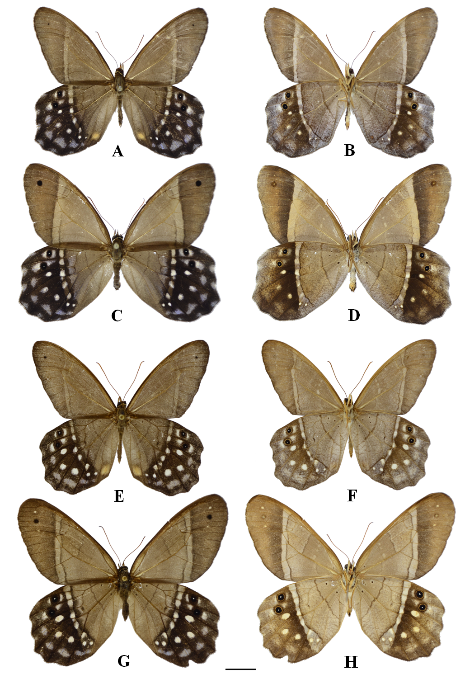
Fig. 1. Pierella lena atlantica ssp. nov.: A-B - Male holotype, dorsal and ventral; C-D – Female allotype, dorsal and ventral. Pierella lena lena: E-F – Male, dorsal and ventral; G-H - Female, dorsal and ventral. Scale = 1 cm.

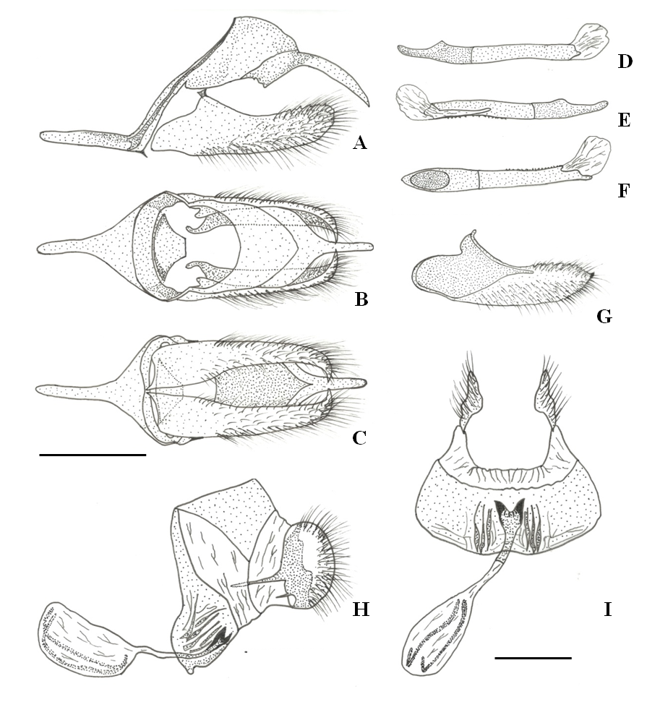
Fig. 2. Pierella lena atlantica ssp. nov. : Male genitalia with aedeagus removed - A. Lateral; B. Dorsal; C. Ventral; D-F - aedeagus, lateral left, lateral right and dorsal; G – lateral left valva, inner view. Female genitalia - H-I – lateral and ventral. Scale = 1 mm.

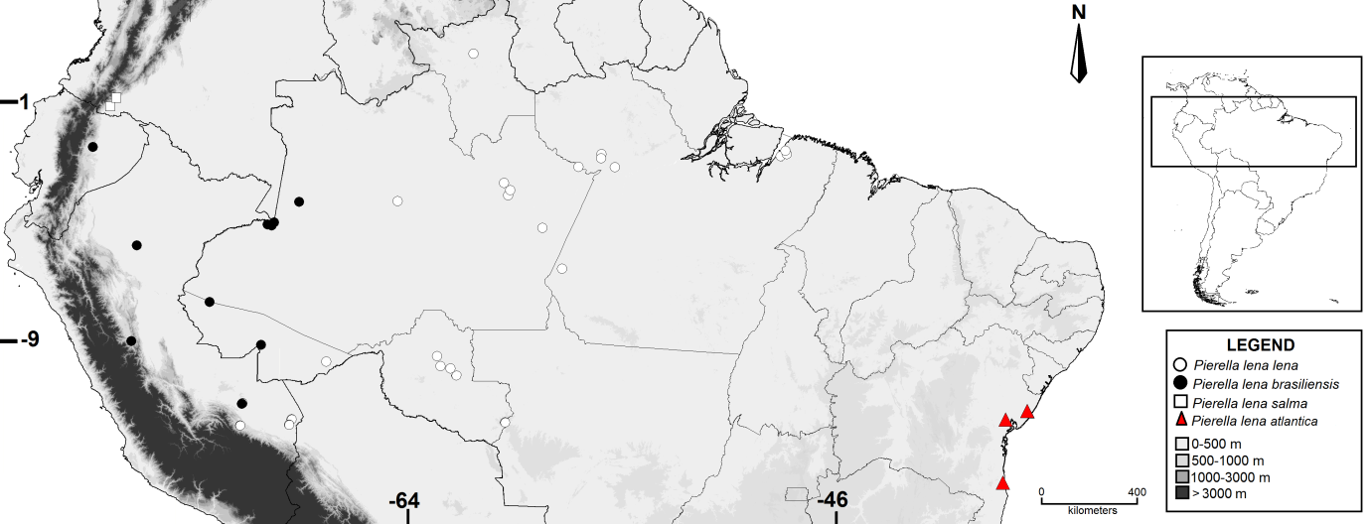
Fig. 3. Distribution map of the of subspecies of Pierella lena showing collection localities.

Author Index
Paluch, M.
Zacca, T.
Siewert, R. R.
Mielke, O. H. H.
Casagrande, M. M.

