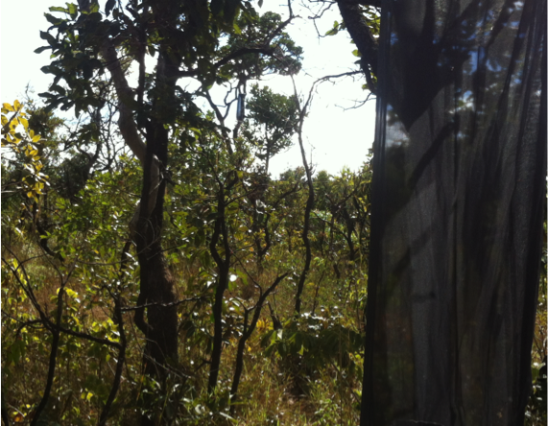
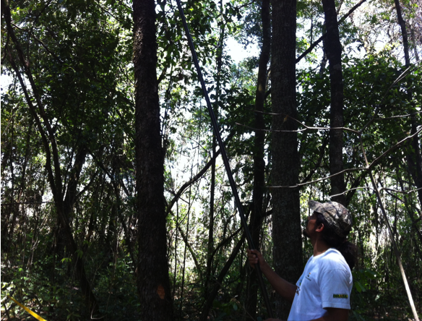
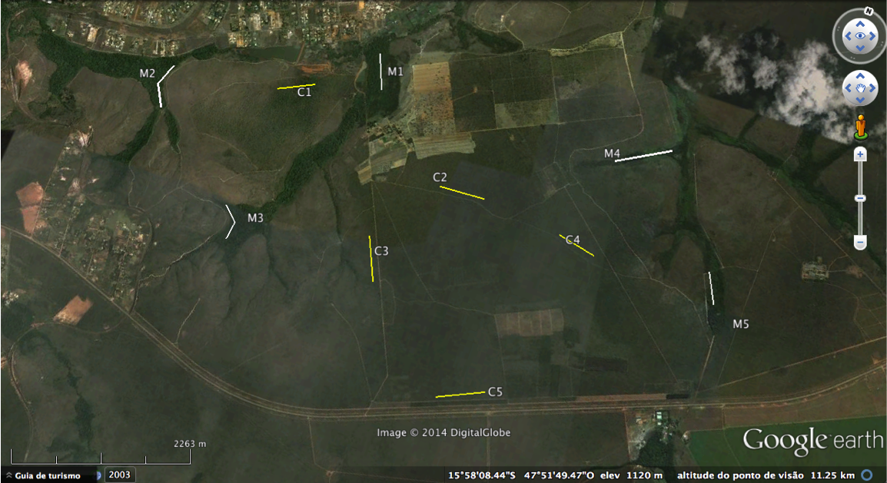

Supplementary file 1. Ten linear transects, with 3 sample plots and 2 bait-traps (understory and canopy) each, distributed in Savanna ("cerrado sensu stricto": C1 – C5) and gallery forest ("mata de galeria": M1 – M5) habitats. The bait-traps were visited from July 2012 to June 2013 and were located in the Fazenda Água Limpa (FAL -UnB) and Reserva Ecológica do Roncador (RECOR), Brasília-DF.

