Running head:

Espinoza-Lozano et al.: 2-6-2018 ms 020618

Membership status:

Norman C. Leppla, 181

Billing contact:

Amanda C. Hodges

University of Florida

Entomology and Nematology Department

1881 Natural Area Drive, Steinmetz Hall

Gainesville, 32611, United States

Phone: +001 352-359-9118

E-mail: achodges@ufl.edu

**Alternatives to a Synthetic Pyrethroid for Controlling Madeira Mealybug (Hemiptera: Pseudococcidae) on Coleus Cuttings**

Lisbeth **Espinoza-Lozano**1,*, Sarahlynne **Guerrero2**, Lance S. **Osborne3**, Norman C. **Leppla2,** Amanda C. **Hodges2**, and Mihai C. **Giurcanu4**

1University of Florida, Entomology and Nematology Department, Gainesville, FL 32611, USA; Escuela Superior Politécnica del Litoral, Centro de Investigaciones Biotecnológicas del Ecuador, Guayaquil, Ecuador; E-mail: [ldespino@ufl.edu](mailto:ldespino@ufl.edu) (L. E. L.)

2University of Florida, Entomology and Nematology Department, Gainesville, FL 32611, USA; E-mail: [slynne89@ufl.edu](mailto:slynne89@ufl.edu) (S. G.), [ncleppla@ufl.edu](mailto:ncleppla@ufl.edu) (N. C. L.), [achodges@ufl.edu](mailto:achodges@ufl.edu) (A. C. H.)

3University of Florida, Mid-Florida Research & Education Center, Apopka, FL 32703, USA; E-mail: [lsosborne@ufl.edu](mailto:lsosborne@ufl.edu)

4University of Florida, Department of Statistics, Gainesville, FL 32611, USA; E-mail: [giurcanu@stat.ufl.edu](mailto:giurcanu@stat.ufl.edu)

*Corresponding author; E-mail: [achodges@ufl.edu](mailto:achodges@ufl.edu)

**Abstract**

Mealybugs are soft-bodied insects that infest a variety of ornamental plants, and early instars are almost undetectable to the human eye. Consequently, insecticide dips containing synthetic pyrethroid-based products are often used in an attempt to kill the cryptic mealybugs and prevent damage to the plants. Dips differ widely, however, in their phytotoxicity, effectiveness in killing mealybugs, and operational efficiency and cost. Therefore, to assess the efficacy of alternative dips, tests were conducted on biorational products for controlling the Madeira mealybug, *Phenacoccus madeirensis* Green, on coleus plants, *Plectranthus* *scutellarioides*, var. Big Red Judy. Initially, phytotoxicity was evaluated using different concentrations and exposure times for dips containing Natur’l oil, dish detergent, Wetcit®, or Vapor Gard®. The highest concentrations of these products for which phytotoxicity could be tolerated were 1%, 1%, 0.1% and 0.1%, respectively, in 30 s dips. Based on the results, these concentrations were used in dips to evaluate their effectiveness in eliminating mealybugs. The most effective biorational product, Natur’l oil, was compared with the commercial standard synthetic pyrethroid, Mavrik Aquaflow® (22.3% tau-fluvalinate), and both killed more than 80% of the nymphs when applied as a 1% aqueous mixture for 30 s. Thus, Natur’l oil can be used instead of the synthetic pyrethroid in a dip for removing Madeira mealybugs from coleus cuttings.

Key Words: insecticide dips; nursery cuttings

**Resumen**

Las cochinillas son insectos de cuerpo blando que infestan una gran variedad de plantas ornamentales, los estadios tempranos de estos insectos son casi imperceptibles para el ojo humano. Las inmersiones de plantas en insecticidas que contienen piretroides sintéticos se usan a menudo para matar las cochinillas crípticas y prevenir potenciales daños las plantas. Las inmersiones difieren ampliamente en su fitotoxicidad, efectividad y costo operacional. Por lo tanto, para evaluar la eficacia de las inmersiones alternativas, se realizaron pruebas en productos para controlar el piojo harinoso, *Phenacoccus madeirensis* Green, en plantas de coleo, *Plectranthus scutellarioides*, var. Big Red Judy. Inicialmente, se evaluó la fitotoxicidad utilizando diferentes concentraciones y tiempos de inmersión en soluciones o emulsiones con aceite natural, detergente para platos, Wetcit® o Vapor Gard®. Las concentraciones más altas de estos productos en las cuales se tolera fitotoxicidad fueron 1%, 1%, 0.1% y 0.1%, respectivamente, a un tiempo de inmersión de 30 s. El producto bioracional más eficaz, fue el aceite natural Natur’l oil que se comparó con el piretroide sintético comercial, Mavrik Aquaflow® (22,3% tau-fluvalinato), y ambos mataron a más del 80% de las ninfas cuando se aplicaron como una mezcla acuosa al 1% por 30 s. Por lo tanto, se puede utilizar aceite natural en lugar del piretroide sintético en inmersión para eliminar las cochinillas en los esquejes de coleo.

Palabras Clave: insecticidas de inmersión; estacas

The Madeira mealybug, *Phenacoccus madeirensis* Green (Hemiptera: Pseudococcidae), is a cosmopolitan polyphagous insect that has been detected on plants in over 60 taxonomic families, including some important agricultural and ornamental species, and is particularly difficult to manage due to its cryptic nature (Chong 2005). At 25oC, female *P. madeirensis* develop from egg to adult in approximately 30 days (Chong et al. 2003). Males require 33 days because they have an additional 4th nymphal instar. The egg stage lasts about 8 days followed by the 1st instar nymph or crawler for another 9 days. The remaining 2 female nymphal instars take 6-7 days each; whereas, the 3 for males last about 7, 3, and 6 days, respectively. The male 2nd instar nymph secretes a waxy filamentous test before molting into the 3rd and 4th instars. Males emerge as non-feeding, winged adults; females are wingless.

Historically, *P. madeirensis* has been controlled by insecticides, such as profenophos, chlorpyriphos, buprofezin, dimethoate, imidacloprid, dinotefuran, thiamethoxam, and tau-fluvalinate, among others (Willmott & Cloyd 2013). These compounds affect different metabolic pathways, e.g., disrupting the insect nervous system or the biosynthesis of chitin (Cloyd & Bethke 2011). However, the frequent and often indiscriminate use of some broad spectrum insecticides has induced insecticide resistance in target insects, as well as caused collateral damage in non-target species. Several of these insecticides also can negatively affect human health (Desneux et al. 2007; Vijverberg & vanden Bercken 1990; Wendt-Rasch et al. 2003; WHO 2009; Saillenfait et al. 2015). Consequently, alternatives to broad spectrum insecticides are needed for controlling *P. madeirensis* on ornamental plants (Guerrero 2014). Biorational insecticides are available (Horowitz et al. 2009; Fishel 2016) but they must be effective and minimize phytotoxicity (Osborne 1986; Cloyd & Bethke 2011).

The objective of this study was to develop an acceptable biorational insecticide dip for coleus cuttings, *Plectranthus scutellarioides* variety Big Red Judy, infested with *P. madeirensis*, and to compare its efficacy with the ornamental plant industry standard insecticide dip, Mavrik Aquaflow® (22.3% tau-fluvalinate;) Wellmark International, Schaumburg, Illinois). Dip treatments are used to eliminate mealybugs from coleus cuttings before they are planted, thus minimizing the level of infestation and damage on full-grown plants.

**Materials and Methods**

MEALYBUG COLONY ESTABLISHMENT AND MAINTENANCE

*The P. madeirensis* used in this study was established on 16 January 2013 with about 100 mealybugs from a greenhouse colony and reared on basil plants at the University of Florida, Mid-Florida Research and Education Center (MREC), Apopka, Florida. The source colony had been collected previously from naturally infested basil plants and propagated for about three generations. Identification of the species was verified and a sample deposited at the Florida State Collection of Arthropods, managed by the Florida Department of Agriculture and Consumer Services, Division of Plant Industry, Gainesville, Florida. We maintained our *P.* *madeirensis* colony . on coleus plants under standard greenhouse conditions at MREC (25-27oC and 14:10 L:D photoperiod). Mealybugs were transferred to new coleus plants monthly by placing the new plants adjacent to heavily infested plants.

The coleus plants, variety Big Red Judi, used in this study were obtained from a local nursery in North Central Florida. Cuttings were removed from plants by selecting healthy 10 to 15 cm long branches, cutting each at the base, removing lower leaves then planting them in 10 cm diam plastic pots filled with Farfard Growing Mix 2/C-2 (Sungro Horticulture, Agawam, Massachusetts) containing Canadian sphagnum peat moss, perlite, vermiculite, dolomitic limestone, and wetting agent. Plants were maintained in the greenhouse on a mist system for 2 weeks that was activated every 10 min. for 10 s from 0800 to 2000 h. Plants were moved to another greenhouse table for regular maintenance using the methods ofCroxton & Kessler (2007). Cuttings from 3 month old coleus plants were used for all tests.

ASSESSMENT OF COLEUS CUTTING PHYTOTOXICITY CAUSED BY BIORATIONAL PRODUCT DIPS

Beginning in March 2013, the following biorational products were tested: Natur’l oil (93% soybean oil, 7% emulsifiers; StollerUSA, Houston, Texas), Publix® Dish Detergent, Ultra, Mild & Gentle (Publix, Lakeland, Florida), Wetcit® (8.15% alcohol ethoxylate surfactant; Oro Agri International), and Vapor Gard® (96% di-1-p-menthene; Miller Chemical and Fertilizer, Hanover, Pennsylvania). Products were mixed in distilled water at concentrations of 0.1%, 0.5%, 1%, and 1.5%. Distilled water alone was also used as a treatment. For each dip, five 10 cm long coleus cuttings, with two fully develop leaves, were simultaneously submerged and lightly agitated for 30 s. This is a typical procedure used by nurseries to treat plant cuttings. Each treatment was repeated twice and cuttings planted in individual 10 cm diameter plastic pots filled with Faford® growing mix. Plants were maintained under the mist system for 4 weeks and watered 12 h per day at intervals of 30 s every 10 min. Phytotoxicity was assessed weekly for 4 weeks using the following categories: chlorosis, leaf curling, chlorotic flecking, necrotic flecking, marginal necrosis, marginal chlorosis, chlorotic streaking, necrotic streaking, holes, tip chlorosis, and tip necrosis. Phytotoxcity symptoms were each assigned numerical values ranging from zero for no damage to 5 for highly damaged plants. This approach to scoring plant damage was adapted from assessments of other ornamental plants treated with insecticides for controlling aphids, scale insects, and mealybugs (Hansen et al. 1992).

EFFICACY OF THE BIORATIONAL PRODUCTS FOR CONTROLLING MEALYBUGS ON COLEUS CUTTINGS

The following biorational product concentrations that resulted in the highest acceptable levels of phytotoxicity on coleus cuttings were assessed for efficacy in killing mealybugs: 1% Natur’l oil, 1% dish detergent, 0.1% Wetcit®, and 0.1% Vapor Gard®. The 1% Natur’l oil dip resulted in a total phytotoxicity rating below 8; 1% dish detergent had a rating of 8.80 but was used because lower concentrations were unlikely to kill mealybugs; 0.1% Wetcit® rated 8.49, the lowest concentration tested; and 0.1% Vapor Gard® at 7.60 had the lowest phytotoxicity rating for that product (Table 1). Individual biorational product dips were used to treat twenty five 10 cm long coleus cuttings each with 2 fully developed leaves. Cuttings were infested with 15 *P. madeirensis* ranging from crawlers to virgin females. Evaluations were completed immediately after dipping and on the subsequent 3rd, 7th and 14th days. Mealybugs were considered dead if they exhibited no movement after being gently touched 3 times with a small moistened paint brush or had a shriveled, hollow and blackened appearance (Hata et al. 1992). The threshold for an effective biorational treatment was 70% mortality. Tests were conducted for each post-dip day as a 4 x 5 randomized complete block design with 5 replicates.

Since the 1% Natur’l oil dip was the most effective biorational treatment with an acceptable level of phytotoxicity in the coleus cuttings, it was evaluated at 5 dip submerge durations: 1, 15, 30, 60, and 120 sec. For each duration, thirty 10 cm long coleus cuttings each with two fully developed leaves were infested with 15 *P. madeirensis* ranging from nymphs to virgin females. Mealybug mortality was assessed as earlier indicated. At this time, submergence in distilled water only, was also used as a treatment. Evaluations followed a 2 x 5 randomized complete block design with 3 replicates.

EVALUATION OF NATUR’L OIL VERSUS MAVRIK AQUAFLOW® DIPS FOR CONTROLLING MEALYBUG NYMPHS ON COLEUS CUTTINGS

Dips comprised of 1% Natur’l oil, or the commercial standard 1.68 g (AI) /100L Mavrik Aquaflow® (22.3% tau-fluvalinate in water), were compared for controlling mealybugs on coleus cuttings. At 24 h prior to testing, fifteen 1st, 2nd, or 3rd instar *P. madeirensis* nymphs were transferred to 2 fully developed leaves on each 10 cm long coleus cutting (Daane et al. 2012). Infested cuttings were agitated for 60 s in a 3 L plastic container filled with either a Natur’l oil or Mavrik Aquaflow®, or distilled water. After treatment, individual cuttings were inserted into a moist 5 x 5 x 3.8 cm rockwool blocks inside a separate 3 L plastic container. Individual containers for each dip were placed randomly on a greenhouse bench and maintained under the mist system for 2 weeks using the same irrigation schedule for plant propagation. Two experienced observers independently counted the number of live mealybugs on each cutting after 1, 7, and 14 days. To avoid contaminating the newly emerged crawlers, ovisacs were removed from the cuttings. Observations were obtained on 5 cuttings per treatment for each of the 3 treatments that utilized a randomized complete block design with 5 replicates.

STATISTICAL ANALYSIS

Mean (?)coleus phytotoxicity levels and mealybug mortality were subjected to the GLIMMIX procedure (SAS/STAT Version 9.3, SAS Institute, Inc., Cary, North Carolina). This procedure fits binary outcomes and accounted for non-normality and non-homogeneous variances. Data for the 6 most symptomatic phytotoxicity ratings were totaled for each concentration of the biorational insecticides and distilled water to generate an overall rating. Differences between cumulative *P. madeirensis* percent mortality for the 4 most promising treatments and water were analyzed using Tukey-Kramer Least Squares Means for multiple comparisons (JMP® Pro 11, SAS Institute, Inc., Cary, North Carolina). Mealybug mean survival over time of the 1% Natur’l oil, 1% Mavrik Aquaflow®, or water dip was compared using the same multiple comparison test. Differences in all analyses were considered significant at *P*<0.05.

**Results**

COLEUS CUTTING PHYTOTOXICITY AND EFFICACY OF BIORATIONAL PRODUCT DIPS FOR CONTROLLING MEALYBUGS

The damage to coleus cuttings caused by biorational insecticide dips was compared for aqueous mixtures of Natur’l oil, dish detergent, Wetcit®, Vapor Gard®, or water (Table 1). The damage was assessed in terms of chlorosis, chlorotic flecking, necrotic flecking, holes, tip chlorosis, and tip necrosis. This kind of damage can render the coleus plants unmarketable, so the phytotoxicity caused by insecticide dips must be minimized. The least amount of phytotoxicity to coleus cuttings occurred with the 0.1% Natur’l oil (7.19) and 0.1% Vapor Gard (7.60) dips and mirrored the effect similar to distilled water. T

After a 30 s dip, mealybug mortality was highest for 1% Natur’l oil and 0.1% Wetcit®, exceeding 90% within 14 days (Fig. 1.). Less effective were 1% dish detergent and 0.1% Vapor Gard® dips. Interestingly, distilled water dip induced greater than 60% cumulative mortality of mealybugs. Because the 0.1% Wetcit dip caused unacceptable phytotoxicity of the cuttings, only the 1% Natur'l oil dip was tested further.

EVALUATION OF NATUR’L OIL DIP DURATION ON MEALYBUG MORTALITY

The 15 s dip was nearly as effective as the longer submergent durations, although the 120 s dip caused significantly higher cumulative mealybug mortality (Fig. 2). Mealybug mortality was significantly lower for the shorter post-treatment periods and at 14 days following the 30 s treatment was about the same as in the previous test (~90%).

EVALUATION OF NATUR’L OIL VERSUS MAVRIK AQUAFLOW® FOR CONTROLLING MEALYBUG NYMPHS ON COLEUS CUTTINGS

Both dips reduced the number of nymphs per cutting to 4 and virtually eliminated them within 14 days (Fig. 3). The distilled water dip also reduced mealybug survival over time by about 40%, suggesting that agitating the cuttings during dipping removes many of the mealybugs.

**Discussion**

A 60 s dip containing 1% Natur’l oil was effective in virtually eliminating *P. madeirensis* nymphs from coleus cuttings within 14 days post-treatment without causing unacceptable phytotoxicity. Natur’l oil is a vegetable oil obtained from soybeans commonly used as a non-ionic surfactant for applying herbicides, fungicides, and insecticides. The insecticidal properties of Natur’l oil are well known, as it has been used effectively to control pests such as whiteflies and mites (Butler et al. 1993; Liu & Stansly 2000; Amer et al. 2001). Several vegetable oils, in addition to soybean oil, also are toxic to soft-bodied insects. (Butler & Henneberry 1990).

Mavrik Aquaflow® formulated at 1% in a 60 s dip similarly controlled *P. madeirensis* on coleus plants. Most mealybugs died within 7 days and none remained after 2 weeks with this product. Osborne (1986) reported that a 60 s dip of Mavrik Aquaflow at the recommended rate consistently reduced *Phenacoccus solani* Ferris, populations by at least 80% on longevity spinach, *Gynura procumbens* (Lour.) Merrill. This product contains a synthetic pyrethroid that has been used extensively in agriculture for many years even though it is highly toxic to parasitoids and predators (Ulber et al. 2010). Moreover, synthetic pyrethroids have induced resistance in several target pests (Zalom et al. 2005).

This study determined that Natur’l oil is as effective as Mavrik Aquaflow® for removing *P. madeirensis* nymphs from coleus cuttings and probably could be used in dips for controlling other insect pests on ornamental plants. Indeed, Natur’l oil could replace Mavrik Aquaflow® or be used in rotation to limit the development of insecticide resistance in this pest(?)target pests. We found that the effective concentration of Natur’l oil and Mavrik Aquaflow to control *P. madeirensis* applied as dips (as well as dip duration) proved to be similar with Natur’l oil costing less and without risk to human health and the environment.

**Acknowledgments**

The authors thank the staff of the Biosecurity Research and Extension Laboratory at the University of Florida, especially undergraduate laboratory technician Carly Anderson, for maintaining the mealybug colonies and evaluating plant damage due to insecticide phytotoxicity. Katherine Houben and Irma Herrera from the Mid-Florida Research and Education Center contributed technical assistance.

**References Cited**

Amer SAA, Momen FM, Saber SA. 2001. A comparative study of the effect of some mineral and plant oils on the two spotted spider mite *Tetranychus urticae* Koch (Acari: Tetranychidae). Acta Phytopathologica et Entomologica Hungarica 36: 165-171.

Butler GD, Henneberry TJ. 1990. Pest control on vegetables and cotton with household cooking oils and liquid detergents. Southwestern Entomologist 15: 123-131.

Butler GD, Henneberry TJ, Stansly PA, Schuster DJ. 1993. Insecticidal effects of selected soaps, oils, and detergents on the sweetpotato whitefly (Homoptera: Aleyrodidae). Florida Entomologist 76: 161-167.

Chong JH, Oetting RD, Van Iersel MW. 2003. Temperature effects on the development, survival, and reproduction of the Madeira mealybug, *Phenacoccus madeirensis* Green (Hemiptera: Pseudococcidae), on Chrysanthemum. Annals of the Entomological Society of America 96: 539–543.

Chong JH. 2005. Biology of the mealybug parasitoid, *Anagyrus loecki*, and its potential as a biological control agent of the Madeira mealybug *Phenacoccus madeirensis*. Thesis, University of Georgia, Athens.

Cloyd RA, Bethke JA. 2011. Impact of neonicotinoid insecticides on natural enemies in greenhouse and interiorscape environments. Pest Management Science 67: 3-9.

Croxton S, Kessler R. 2007. Greenhouse Production of Coleus. Alabama Cooperative Extension System, ANR-1314.

Daane KM, Almeida RP, Bell VA, Walker JT, Botton M, Fallahzadeh M, Zaviezo T. 2012. Biology and management of mealybugs in vineyards, pp. 271-307. *In* Bostanian NJ, Vincent C, Isaacs R [eds.], Arthropod Management in Vineyards. Springer, Netherlands.

Desneux N, Decourtye A, Delpuech JM. 2007. The sublethal effects of pesticides on beneficial arthropods. Annual Review of Entomology 52: 81-106.

Fishel FM. 2016. The EPA Conventional Reduced Risk Pesticide Program. UF/IFAS EDIS

Guerrero S. 2014. Development and evaluation of biorational dips for ornamental cuttings infested with the Madeira mealybug, *Phenacoccus madeirensis* Green. Thesis, University of Florida, Gainesville.

Hansen JD, Hara AH, Tenbrink V. 1992. Insecticidal dips for disinfesting commercial tropical cut flowers and foliage. Tropical Pest Management 38: 245-249.

Hata TY, Hara AH, Jang EB, Imaino LS, Hu BK, Tenbrink VL. 1992. Pest management before harvest and insecticidal dip after harvest as a systems approach to quarantine security for red ginger. Journal of Economic Entomology 85: 2310-2316.

Horowitz AR, Ellsworth PC, Ishaaya I. 2009. Biorational pest control–an overview, pp. 1-20. *In* Ishaaya I, Horowitz AR [eds.], Biorational Control of Arthropod Pests. Springer, Netherlands.

Liu T, Stansly P. 2000. Insecticidal activity of surfactants and oils against silverleaf whitefly (*Bemisia argenticolii*) nymphs (Homoptera: Aleyrodidae) on collards and tomato. Pest Management Science 56: 861-866.

Osborne LS. 1986. Dip treatment of tropical ornamental foliage cuttings in fluvalinate to prevent the spread of insect and mite infestations. Journal of Economic Entomology 79: 465-470.

Pless CD, Deyton DE, Sams CE. 1995. Control of San Jose scale, terrapin scale, and European red mite on dormant fruit trees with soybean oil. HortScience 30: 94-97.

Saillenfait AM, Ndiaye D, Sabaté JP. 2015. Pyrethroids: Exposure and health effects - An update. International Journal of Hygiene and Environmental Health 218: 281-292.

Ulber B, Klukowski Z, Williams IH. 2010. Impact of insecticides on parasitoids of oilseed rape pests, pp. 337-355. *In* Williams IH [ed.], Biocontrol-Based Integrated Management of Oilseed Rape Pests. Springer, Netherlands.

Vijverberg H, vanden Bercken J. 1990. Neurotoxicological effects and the mode of action of pyrethroid insecticides. Critical Reviews in Toxicology 21: 105-123.

Wendt-Rasch L, Friberg-Jensen U, Woin P, Christoffersen K. 2003. Effects of the pyrethroid insecticide cypermethrin on a freshwater community studied under field conditions. II. Direct and indirect effects on the species composition. Aquatic Toxicology 63: 373-389.

WHO. 2009. The WHO Recommended Classification of Pesticides by Hazard and Guidelines to Classification. World Health Organization. <http://www.who.int/ipcs/publications/pesticides_hazard_2009.pdf?ua=1>

Willmott A, Cloyd R. 2013. Mealybugs and systemic insecticides. Greenhouse Product News. <http://www.gpnmag.com/mealybugs-and-systemic-insecticides>

Zalom F, Toscano N, Byrne F. 2005. Managing resistance is critical to future use of pyrethroids and neonicotinoids. California Agriculture 59: 11-15.

**Table 1**. Damage ratings for coleus cuttings agitated for 30 s in biorational product dips1.

|  |  |  |  |  |  |  |  |  |  |
| --- | --- | --- | --- | --- | --- | --- | --- | --- | --- |
| Percent | Chlorosis | Chlorotic Flecking | Necrotic Flecking | Holes | Tip Chlorosis | | Tip Necrosis | | Total |
| Natur'l oil | | | | | | | | | |
| 0.1% | 1.43 i | 1.43 j | 1.16 hi | 1.11 ghi | 1.02 f | | 1.04 fg | | 7.19 |
| 0.5% | 1.52 ghi | 1.51 ij | 1.16 hi | 1.09 hi | 1.03 f | | 1.02 g | | 7.33 |
| 1.0% | 1.54 ghi | 1.54 jhi | 1.21 fghi | 1.08 i | 1.02 f | | 1.21 bcd | | 7.59 |
| 1.5% | 1.92 d | 1.88 de | 1.50 bc | 1.18 fgh | 1.06 cdef | | 1.09 efg | | 8.63 |
| Water | 1.49 i | 1.49 j | 1.17 hi | 1.15 ghi | 1.08 cde | | 1.04 g | | 7.40 |
|  |  |  |  |  |  | | *Mean* | | 7.63 |
| Detergent | | | | | | | | | |
| 0.1% | 1.54 ghi | 1.53 jhi | 1.20 fghi | 1.21 efg | 1.06 cdef | | 1.16 cde | | 7.70 |
| 0.5% | 1.65 fg | 1.65 gh | 1.41 cde | 1.25 def | 1.07 cdef | | 1.20 bcd | | 8.23 |
| 1.0% | 1.89 de | 1.85 de | 1.61 ab | 1.31 cde | 1.14 ab | | 1.00 g | | 8.80 |
| 1.5% | 1.90 d | 1.86 de | 1.65 a | 1.36 bc | 1.16 a | | 1.20 bcd | | 9.13 |
| Water | 1.50 hi | 1.50 j | 1.17 hi | 1.19 fgh | 1.03 ef | | 1.05 fg | | 7.44 |
|  |  |  |  |  |  | | *Mean* | | 8.26 |
| Wetcit® | | | | | | | | | |
| 0.1% | 1.76 ef | 1.71 fg | 1.29 efg | 1.41 bc | | 1.04 def | | 1.29 ab | 8.49 |
| 0.5% | 2.07 c | 1.96 cd | 1.43 cd | 1.40 bc | | 1.07 cdef | | 1.25 bc | 9.16 |
| 1.0% | 2.29 b | 2.13 b | 1.61 ab | 1.65 a | | 1.06 cdef | | 1.26 bc | 10.00 |
| 1.5% | 2.26 b | 2.09 b | 1.67 a | 1.56 a | | 1.03 ef | | 1.30 ab | 9.91 |
| Water | 1.84 de | 1.82 ef | 1.25 fgh | 1.43 b | | 1.03 f | | 1.23 bc | 8.60 |
|  |  |  |  |  | |  | | *Mean* | 9.23 |
| Vapor Gard® | | | | | | | | | |
| 0.1% | 1.62 fgh | 1.62 ghi | 1.12 i | 1.16 fghi | | 1.07 cdef | | 1.03 g | 7.60 |
| 0.5% | 1.81 de | 1.79 ef | 1.31 def | 1.20 fgh | | 1.10 bc | | 1.03 fg | 8.23 |
| 1.0% | 2.19 bc | 2.02 bc | 1.52 bc | 1.33 cd | | 1.09 bcd | | 1.13 def | 9.28 |
| 1.5% | 2.58 a | 2.31 a | 1.52 bc | 1.31 cde | | 1.07 cdef | | 1.37 a | 10.15 |
| Water | 1.53 ghi | 1.53 ij | 1.20 fgi | 1.12 ghi | | 1.02 f | | 1.05 fg | 7.45 |
|  |  |  |  |  | |  | | *Mean* | 8.54 |
| F | 33 | 20.08 | 25.72 | 8.92 | | 11.58 | | 12.25 |  |
| df | 12,948 | 12,948 | 12,948 | 12,948 | | 12,948 | | 12,948 |  |
| P | <0.0001 | <0.0001 | <0.0001 | <0.0001 | | <0.0001 | | <0.0001 |  |

1Means followed by the same letter within a column are not significantly different (P>0.05, Tukey-Kramer)

**Figure captions**

**Fig** **1.** Cumulative mean (+SE) percent mortality of *Phenacoccus madeirensis* on day 1, 3, 7 and 14 resulting from biorational product dips and distilled water. Different letters indicate significant differences between treatments on the successive days (Tukey-Kramer least squares means for multiple comparisons, P>0.05).

**Fig 2.** Cumulative mean (+SE) percent mortality of *Phenacoccus madeirensis* on day 1, 3, 7 and 14 resulting from a 1% Natur’l oil dip of 1, 15, 30, 60 or 120 s duration. Different letters indicate significant differences between treatment durations on the successive days (Tukey-Kramer least squares means for multiple comparisons, P>0.05).

**Fig 3.** Mean number of *Phenacoccus madeirensis* on coleus cuttings at day 0, 1, 7 and 14 after being agitated for 60 s in a dip containing 1% Natur’l oil, 1%, Mavrik Aquaflow® (22.3% tau-fluvalinate in water), or distilled water.

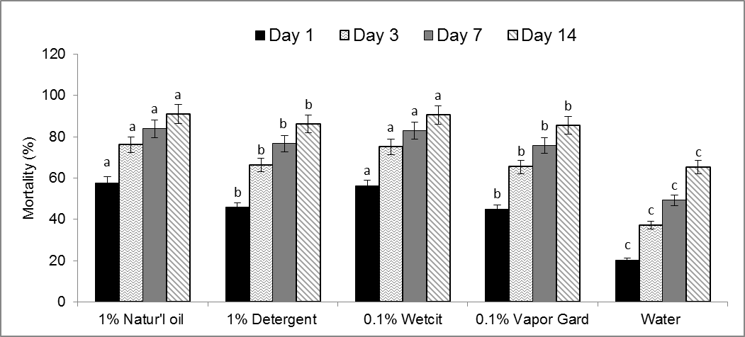

**Fig** 1. Cumulative mean (+SE) percent mortality of *Phenacoccus madeirensis* on day 1, 3, 7 and 14 resulting from biorational product dips. Different letters indicate significant differences between treatments on the successive days (Tukey-Kramer least squares means for multiple comparisons, P>0.05).

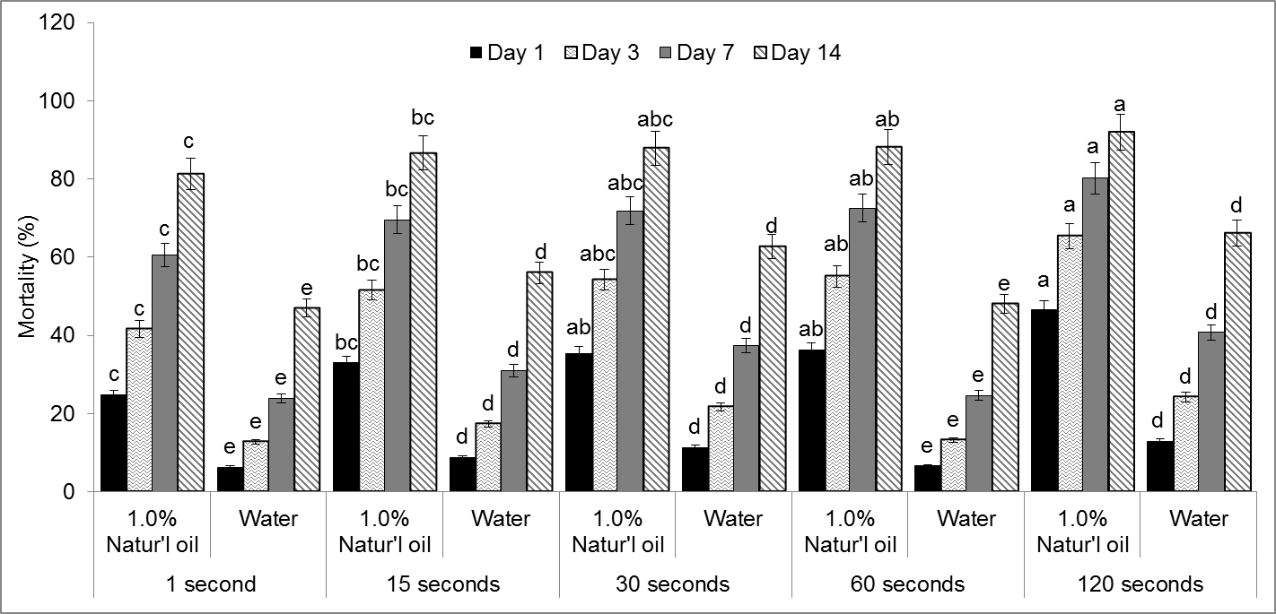

**Fig 2**. Cumulative mean (+SE) percent mortality of *Phenacoccus madeirensis* on day 1, 3, 7 and 14 resulting from a 1% Natur’l oil dip of 1, 15, 30, 60 or 120 s duration. Different letters indicate significant differences between treatment durations on the successive days (Tukey-Kramer least squares means for multiple comparisons, P>0.05).

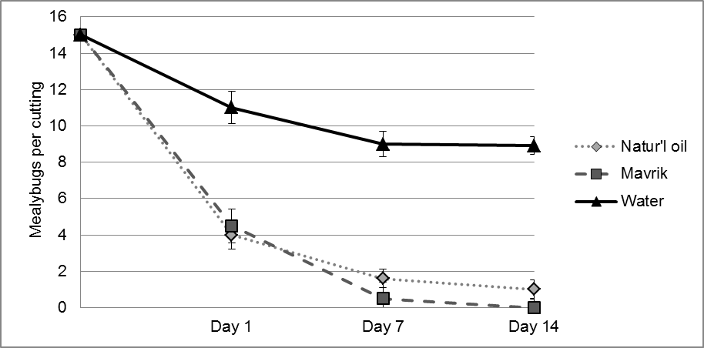

**Fig 3**. Mean number of *Phenacoccus madeirensis* on coleus cuttings at day 0, 1, 7 and 14 after being agitated for 60 s in a dip containing 1% Natur’l oil, 1%, Mavrik Aquaflow ®(22.3% tau-fluvalinate in water), or water.