Fig. 4

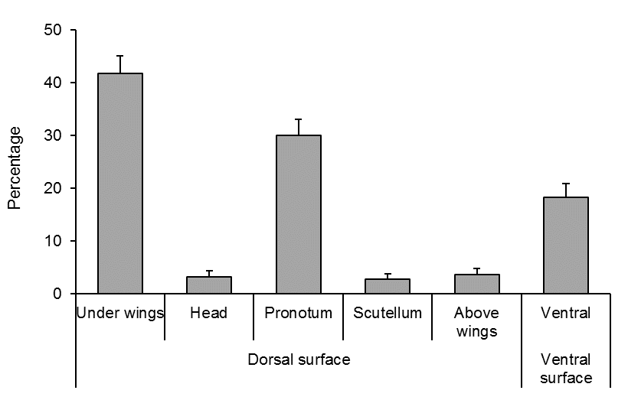

82% \*\*\*

18%