Fig. 3

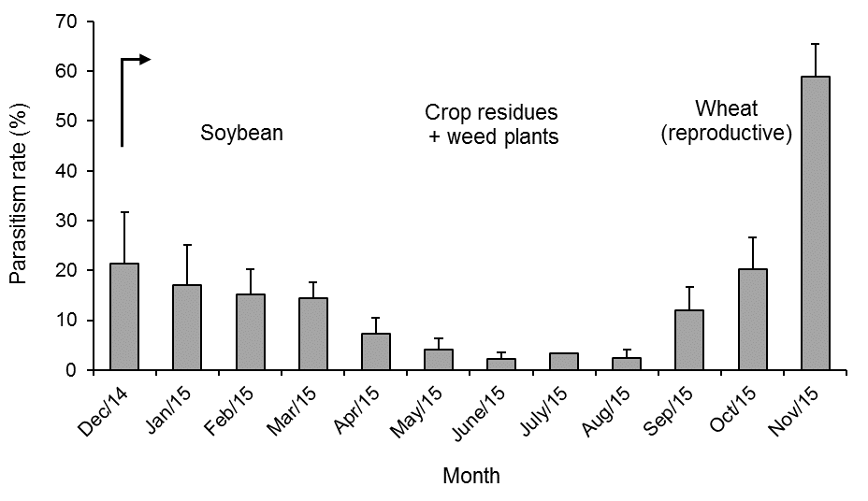

Native plant + soybean