OJS 3 for EDIS Reviewers
Adapted for use by EDIS reviewers from “Chapter 15: Reviewing” in Learning OJS 3.1: A Visual Guide to Open Journal Systems
(CC BY 4.0)
As a reviewer, you will learn of the review request via email or by checking your dashboard at http://journals.flvs.org/edis:
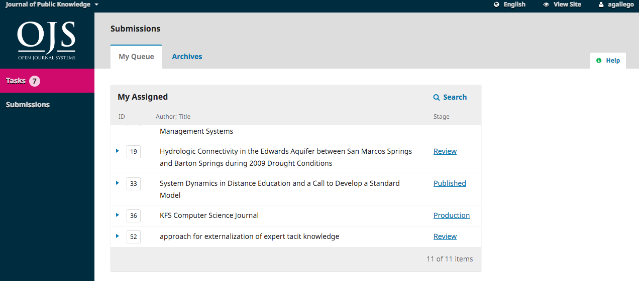
From the My Assigned list, find the title and Review link. This image is of a double-blind peer review process. In EDIS, you will see the authors names listed in bold above the title. The EDIS site is configured to conceal reviewer identities from the author, but show the authors names to reviewers.
Selecting the Review link will take you to the first review step in the submission record.
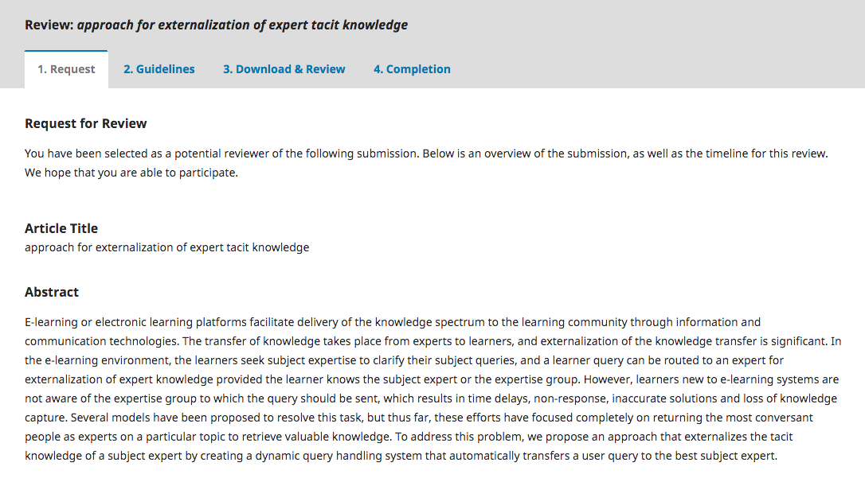
This first step consists of the following sections:
- Request for Review: provides some text inviting you to act as a reviewer.
- Article Title: provides the title of the article.
- Abstract: provides the abstract text.
Further down the screen, you will find additional information.
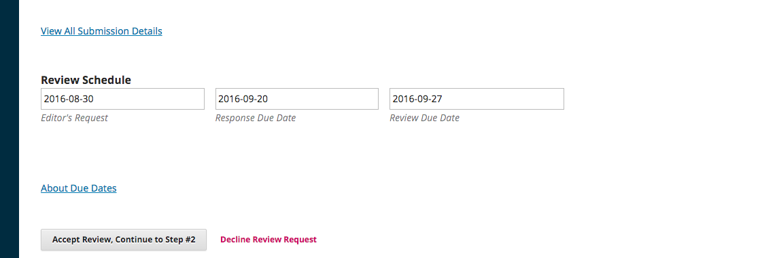
The View All Submission Details link will open a window with additional information, including all the metadata:
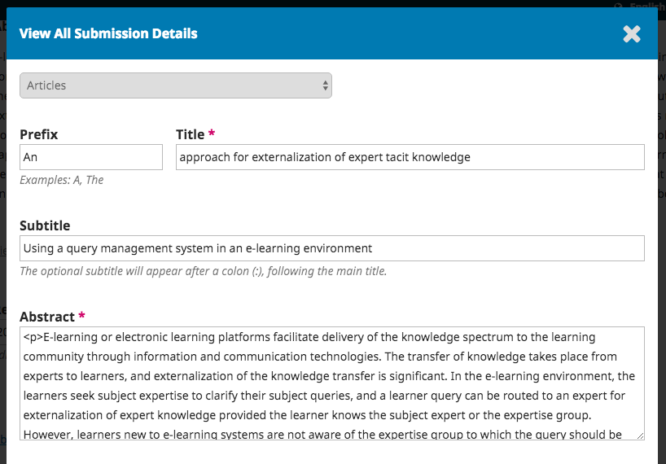
Note that none of these fields are editable by the reviewer. They are only provided to help you conduct a thorough review.
Close this window and move further down the screen. From here you can see the Review Schedule, including all the relevant due dates.
From here, you can decline or accept the review. If you decline, you will be dropped from the process. If you accept, you will move to review step 2, where you would be able to read any reviewer guidelines provided by the journal.
NOTE: In compliance with the EU GDPR regulation, you must check the box agreeing to have your data stored and collected according to our privacy statement to continue in the process.
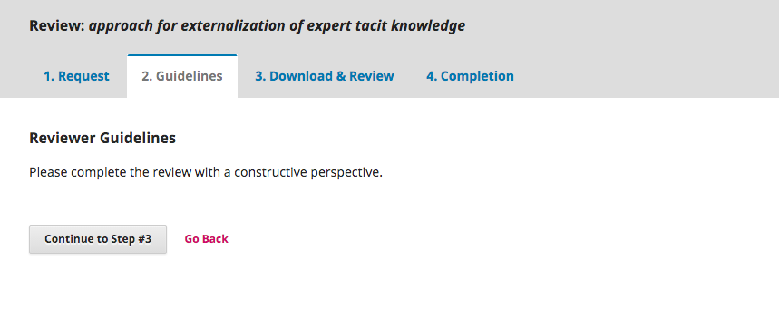
Hit Continue to move to step 3. From here you can download a copy of the review files and enter your review comments. The first window is for comments to the editor and the author; the second window is just for the editor.
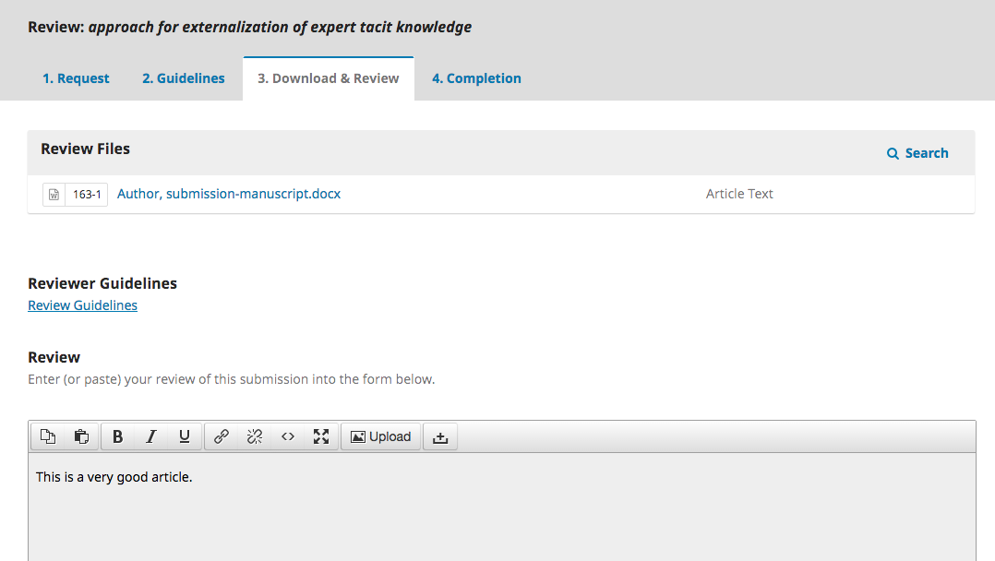
Once you have read the paper and added your comments, scroll down the page to optionally upload a marked-up copy of the review file (to keep your review anonymous, remember to strip any personal identification from the file before uploading it).
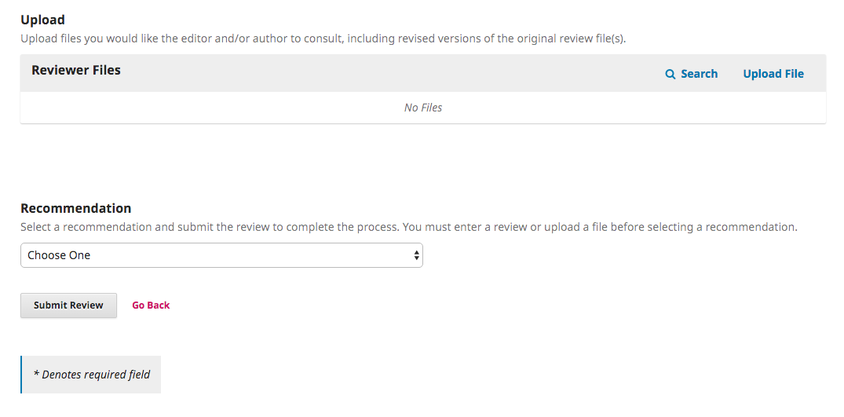
Next, you must make your recommendation using the dropdown menu. Your choices include:
- Accept Submission: it is ready to go to Copyediting as is.
- Revisions Required: it requires minor changes that can be reviewed and accepted by the editor.
- Resubmit for Review: it requires major changes and another round of peer review.
- Resubmit Elsewhere: it doesn’t seem like a good fit for the focus and scope of this journal.
- Decline Submission: it has too many weakness to ever be accepted.
- See Comments: if none of the above recommendations make sense, you can leave a comment for the editor detailing your concerns.
Finally, hit the Submit Review button to complete your task. You’ll be asked to confirm. Until you confirm the review, the system will consider you to still be working on it.
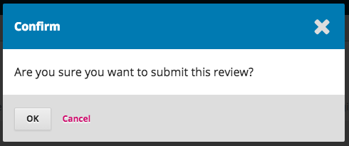
Hit OK. You will be taken to the final confirmation screen thanking you for your work.
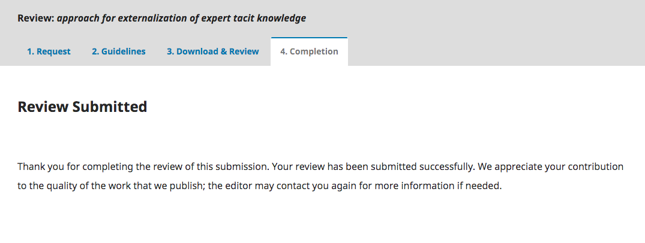
That’s it! The review is now complete.

