General comments:
The authors wish to thank the Editor and Reviewer for their timely review and helpful comments.

Response to Reviewer A:
1. If one year of data is presented, are the authors confident in the results? If the trial is planned for multiple years are the authors planning on publishing each year separately?

Response: This manuscript is a continuation of a series since 2013 of annual fungicide results from Jay, FL. The caveat is stated that the data are from only one site-year and should be taken in context of other site-years. The treatments chosen in this study are part of a multi-site, regional trial in which annual changes to the treatments are based on new formulations of product, new company recommendations that the industry makes to growers, and past experience. Response to markets also necessitates altering treatments on occasion. For example, the 2016 EU restrictions on propiconazole essentially removed formulations containing that active ingredient from the market, and those programs that contained propiconazole were replaced with other programs. In that respect, growers need comparisons of current, industry-recommended spray programs so that they can compare programs within their region.

Regarding future work, we envision the future studies will include a set of ‘core’ treatments that are not meant to change annually, as well as a set of ‘flex’ treatments that can be used to improve upon the core treatments. We plan to continue to publish annual data as part of this series, but we will include data to compare core treatments in subsequent years so that we can see which programs consistently perform under local conditions.

2. The paragraph on statistical analyses is too complicated for a lay audience to understand.

Response: It is true that the statistical analyses required some non-parametric analyses in order to account for heteroscedasticity. The rationale for inclusion of the detailed description was that only readers who are interested in how the analyses were conducted would be interested in this section. We included more detail in this section at the request of previous reviewers who wanted to know how we handled heteroscedasticity in some of our response variables. However, we also recognize that ‘readability’ is important to the audience as well. As a result of the various criticisms, we offer the following as a suggested alternative in the analysis section, if the reviewer believes it clarifies or otherwise improves the manuscript. Although we prefer the more detailed description, we would appreciate feedback from the reviewer if the following text is preferred.

“Statistical analyses were conducted using Proc Mixed within SAS 9.4. Only TSWV and end-of-season leaf spot data had unequal variances. These data were non-parametrically modeled within PROC GLIMMIX. Other response variables, including white mold and yield data, did not violate the homoscedasticity assumption. Repeated measures data were regressed on time (Littell, et al., 2006). Replication was held as a random effect and fungicide program and time were held as fixed effects. Multiple pairwise means separation tests were conducted at the 95% confidence level using Tukey Honest Significant Difference (HSD) Test with the %pdmix800 macro in SAS 9.4 (Saxton, 1998) unless otherwise stated.”

For your convenience, the previous version read as follows:
“Statistical analyses were conducted using Proc Mixed within SAS 9.4. Homogeneity of variances was tested using Levene’s test within PROC GLM at α = 0.05. Only TSWV and end-of-season leaf spot data had unequal variances. These data were non-parametrically modeled within PROC GLIMMIX by adjusting the degrees of freedom for unequal variances using the DDFM=SATTERTHWAITE option. Other response variables, including white mold and yield data, did not violate the heteroscedasticity assumption. Repeated measures data were regressed on time using an unstructured (TYPE=UN) error structure because of unequally spaced repeated measures (Littell, et al., 2006). Replication was held as a random effect and fungicide program and time were held as fixed effects. Multiple pairwise means separation tests were conducted at the 95% confidence level using Tukey Honest Significant Difference (HSD) Test with the %pdmix800 macro in SAS 9.4 (Saxton, 1998) unless otherwise stated.”

3. 2nd paragraph of results, states that leaf spot defoliation was 50% or less. At what level does leaf spot defoliation cause yield losses?

Response: Yield losses to leaf spot are reported to be up to 50% (Smith and Littrell, 1980) but there are few studies that attempt to quantify leaf spot defoliation threshold impacts on yield. The effects of defoliation on yield in peanut are complicated by a temporal component; that is, defoliation during pegging is likely to have a greater impact on yield than defoliation close to harvest, so a single ‘threshold’ value is not practical. Defoliation effects on yield may also depend by genotype as well: some cultivars may have more resistance to leafspot defoliation, yet the lesioned area reduces yield even though it did not defoliate. In addition, defoliation effects on yield are not the same from year to year nor from site to site. For example, see the data below (Smith and Littrell, 1980), which shows defoliation effects on Florunner peanut yield at two sites during two years.

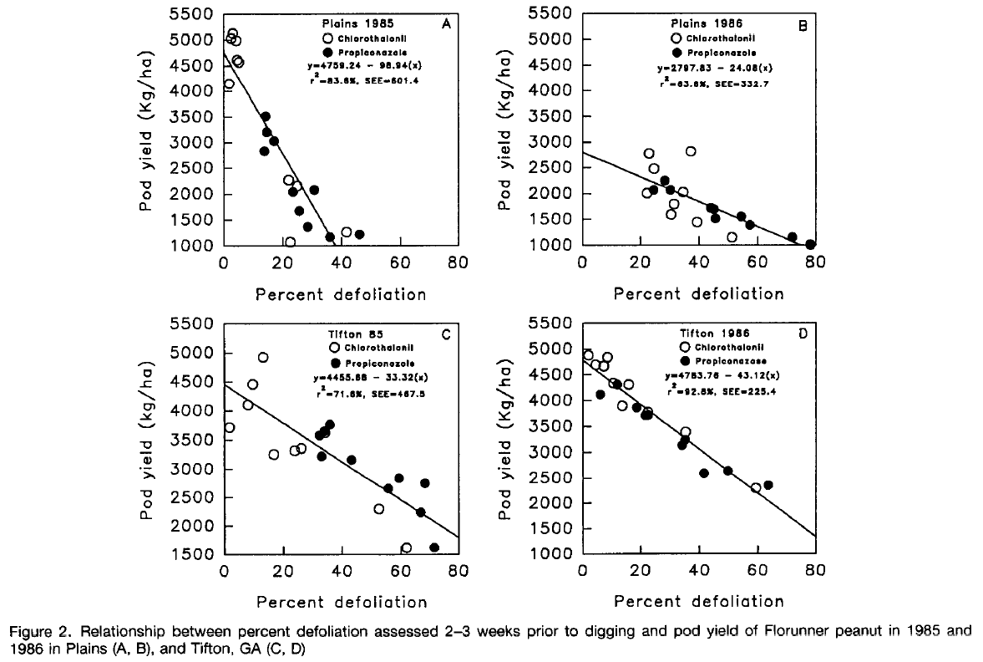

That said, the crux of the reviewer’s question is likely asking why is the 50% threshold worth pointing out? Dr. Culbreath showed that 66% mechanical defoliation of GA-06G did not reduce yield (unpublished), but again, timing, year, cultivar, and disease pressure will be significant variables. Regardless of the actual number, it is well known that peanut can withstand large amounts of defoliation before yield loss is expected. In the end, we felt that highlighting the fact that all programs kept defoliation to less than 50% served to contextualize the efficacy of the programs.

4. Figures 2 and 5 are difficult to see and interpret, make sure that they can be enlarged in final version of article.

Response: We agree. We kindly request the EDIS editing team to enlarge these figures. We can provide higher resolution figures if needed.

