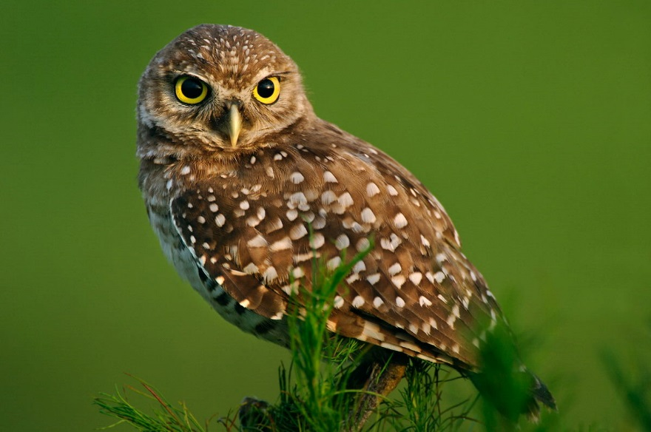

Photo By: Carlton Ward Jr.

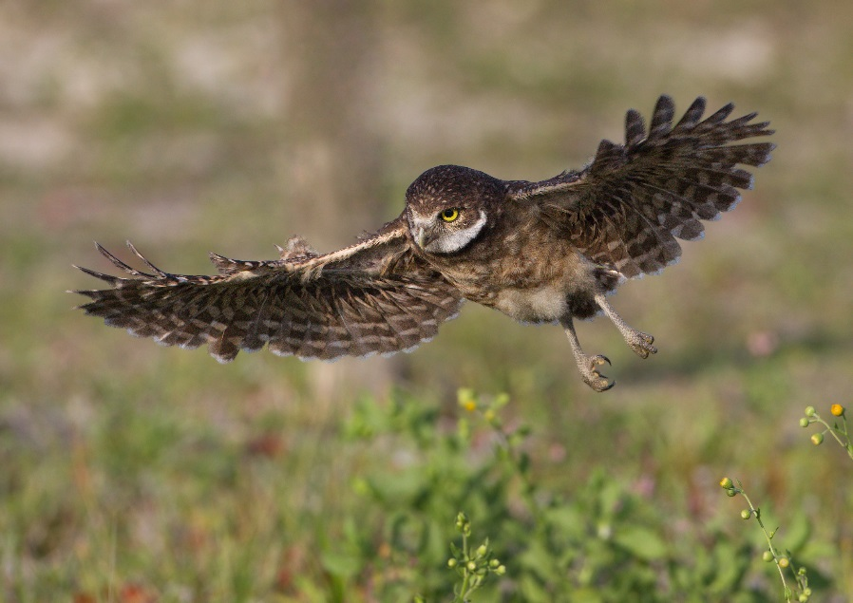

Photo By: Ron Bielefeld

For timeline (created by IFAS graphics design):

1874 – First recorded Florida burrowing owl observation

1896 – Changes to breeding habitat first observed

1938 – Breeding range expansion recorded

1950 – Decline in owl populations on Kissimmee Prairie

1979 – Listed as a “Species of Special Concern” by FWC

1999 – First statewide census conducted, agricultural land largely unaccounted for

2013 – Burrowing owl recommended as state threatened species by FWC

2017 – Burrowing owl classified as state threatened species in January

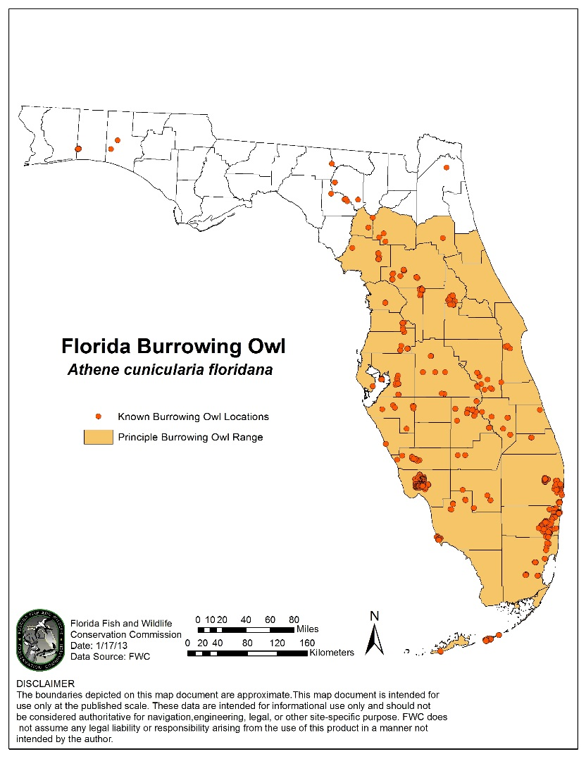

Courtesy of FWC

Types of Burrows (All Photos By: Julie Burford)

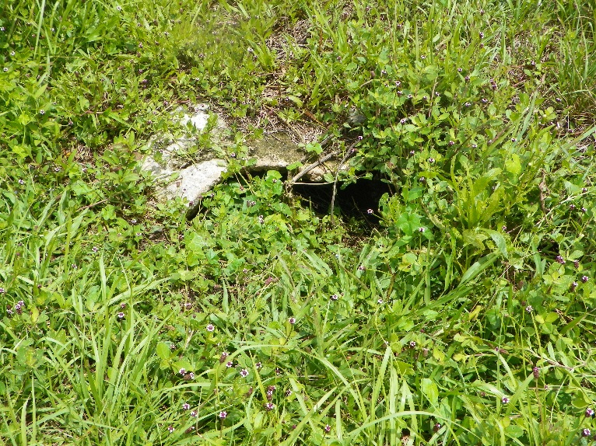

*Burrow under limestone outcropping*

*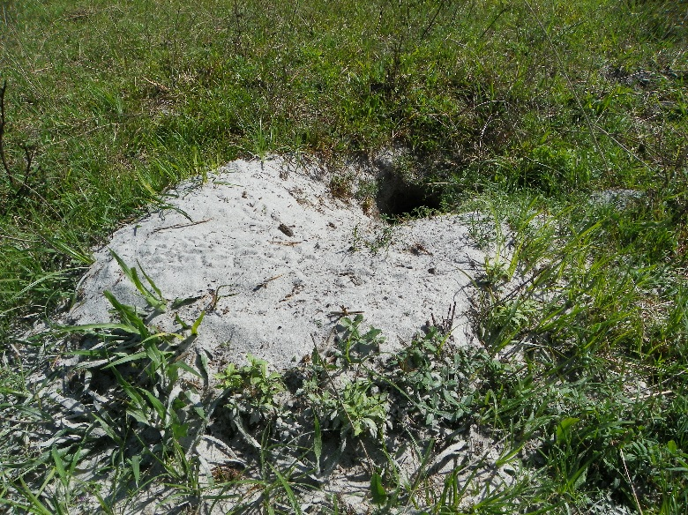*

*Burrow on open rangeland*

*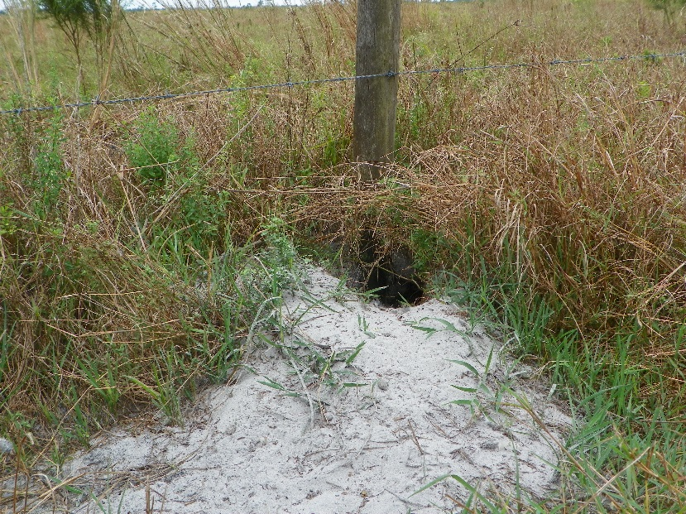*

*Burrow along fence line*

*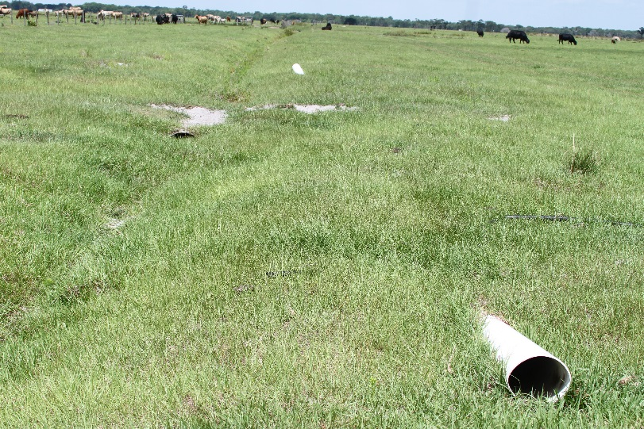*

*Burrow in abandoned PVC pipe*

*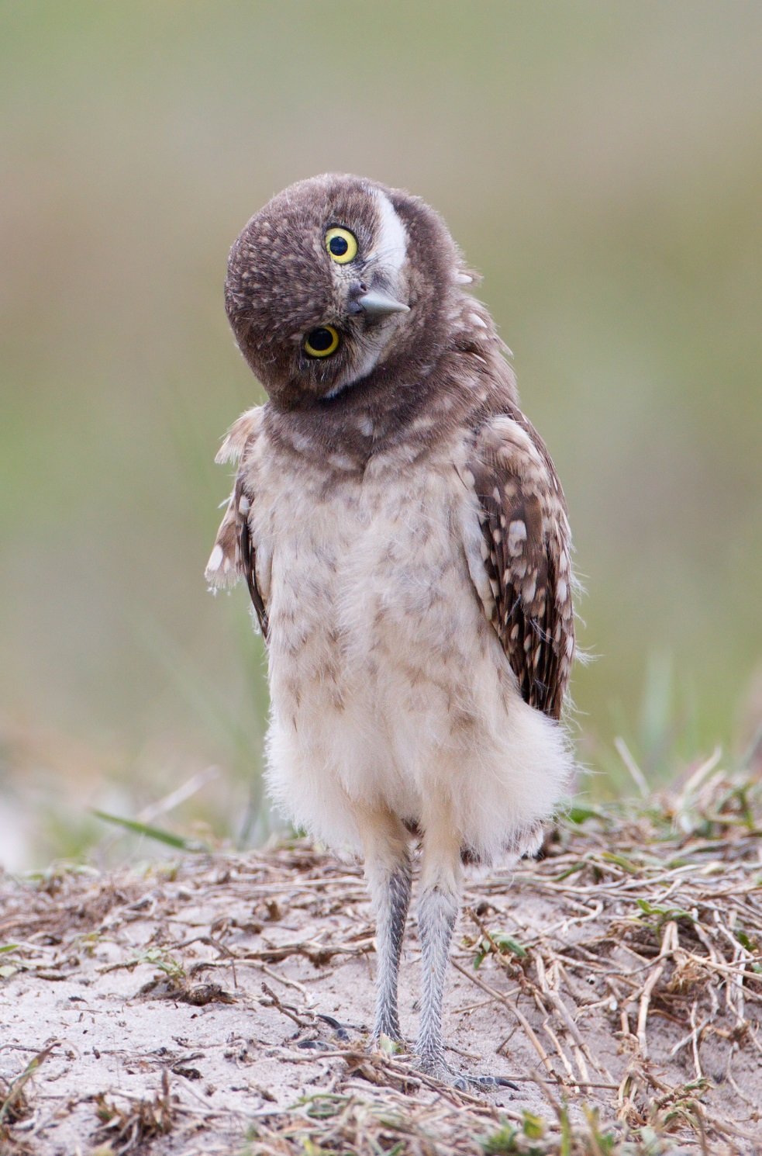*

Photo By: Ron Bielefeld