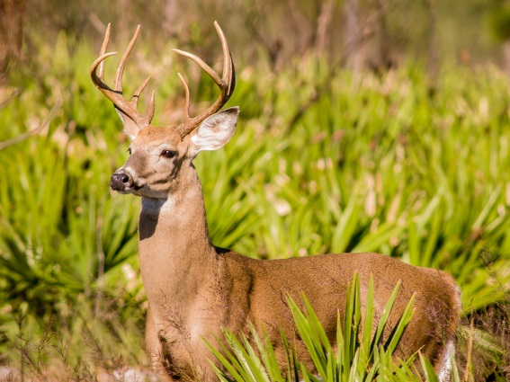

Photo By: Reed Bowman

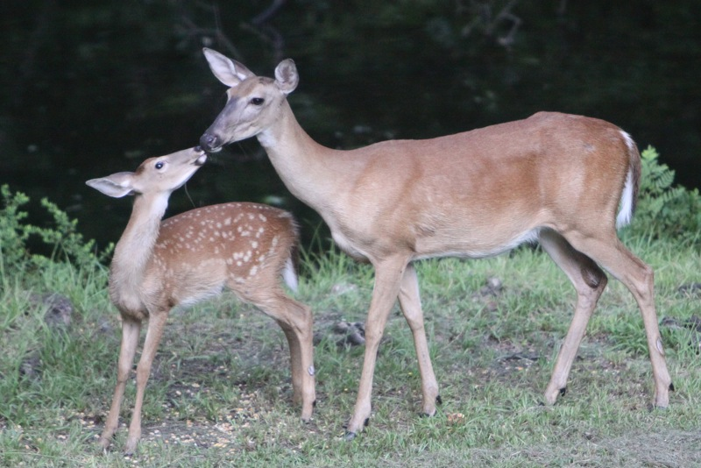

Photo By: Dennis Adair

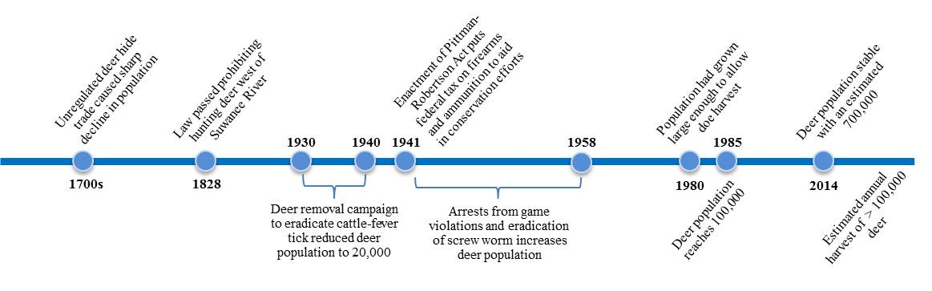

Image By: UF-IFAS Graphics Design

*Delete last bullet “Estimated annual harvest of > 100,000 deer”*

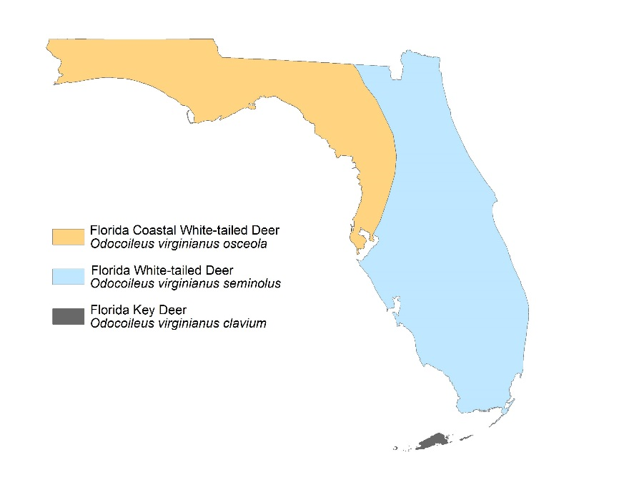

Image By: UF-IFAS

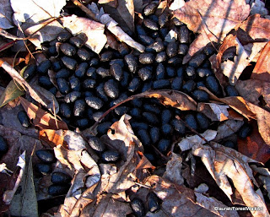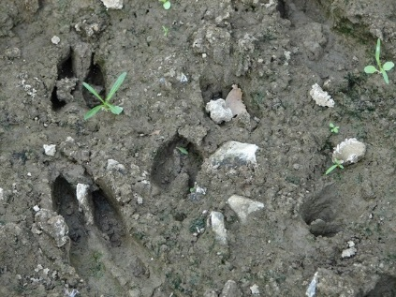Tracks & Scat



Photos By: UF-IFAS

Pre-rut

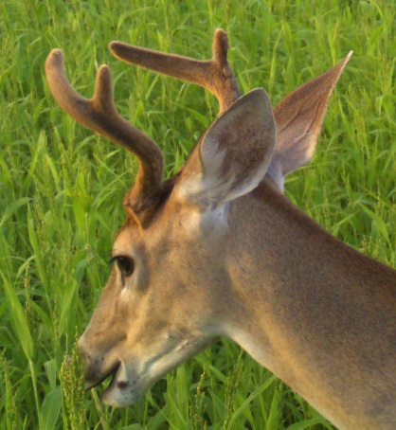

Photo By: Steve Demarais, MSU

*Increasing day-length and testosterone trigger antler growth covered in “velvet”.*

Rut

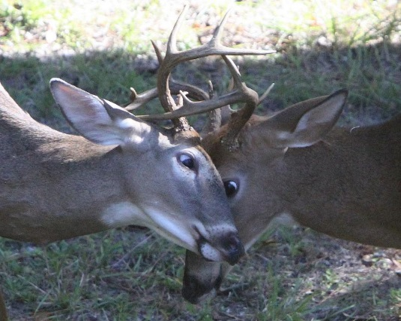

Photo By: Dennis Adair

*Bucks rub antlers to remove velvet and often spar to assert dominance. Does go into estrous.*

Post-rut

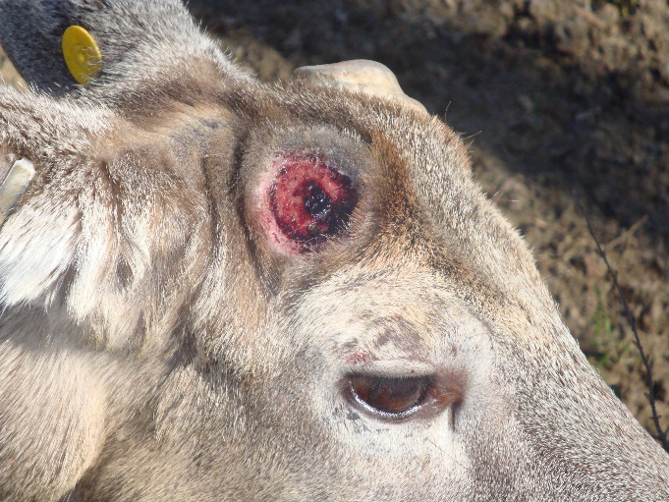

Photo By: Steve Demarais, MSU

*Antlers are shed and new antlers start growing soon after.*

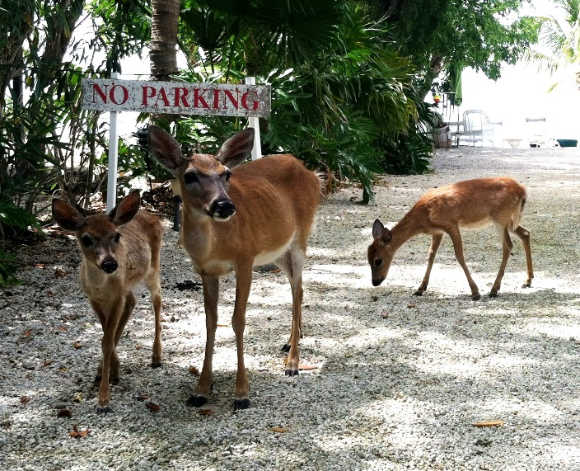

Photo By: Kristin Lajeunesse