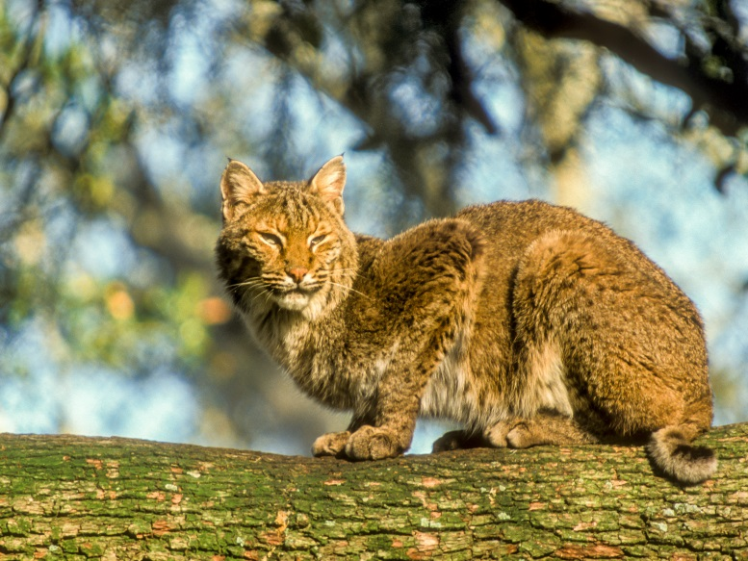

Photo By: Reed Bowman

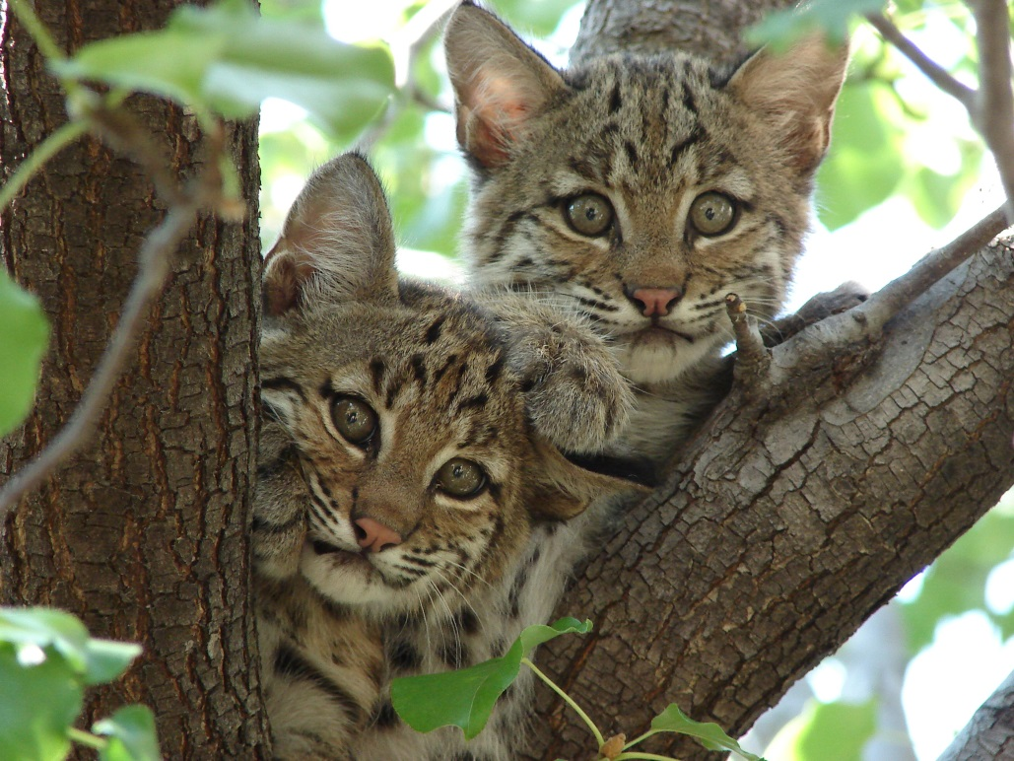

Photo By: Summer M. Tribble

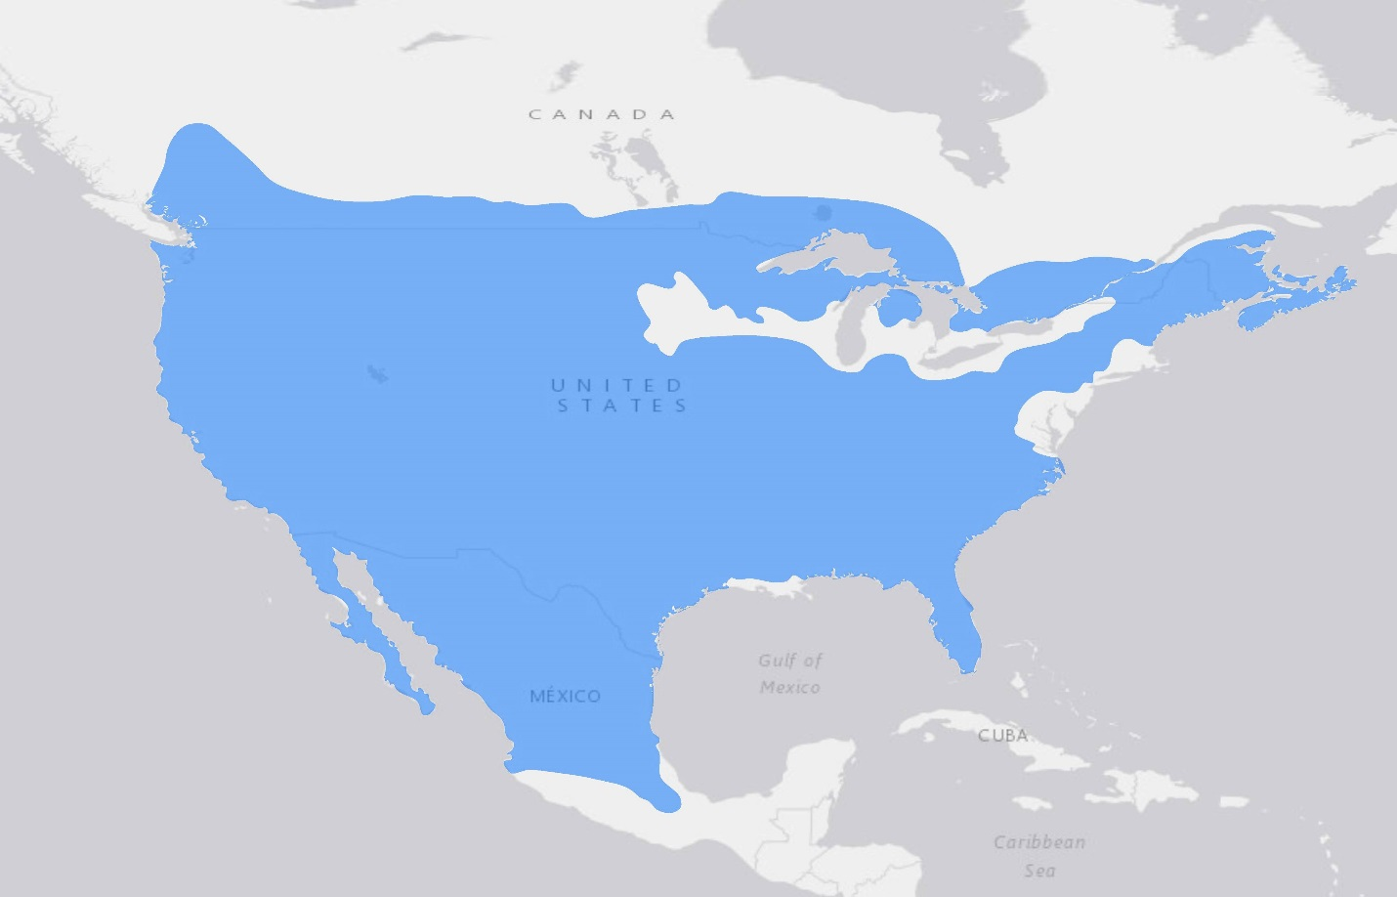

NatureServe and IUCN (International Union for Conservation of Nature, 2016. Lynx rufus <http://www.iucnredlist.org>.

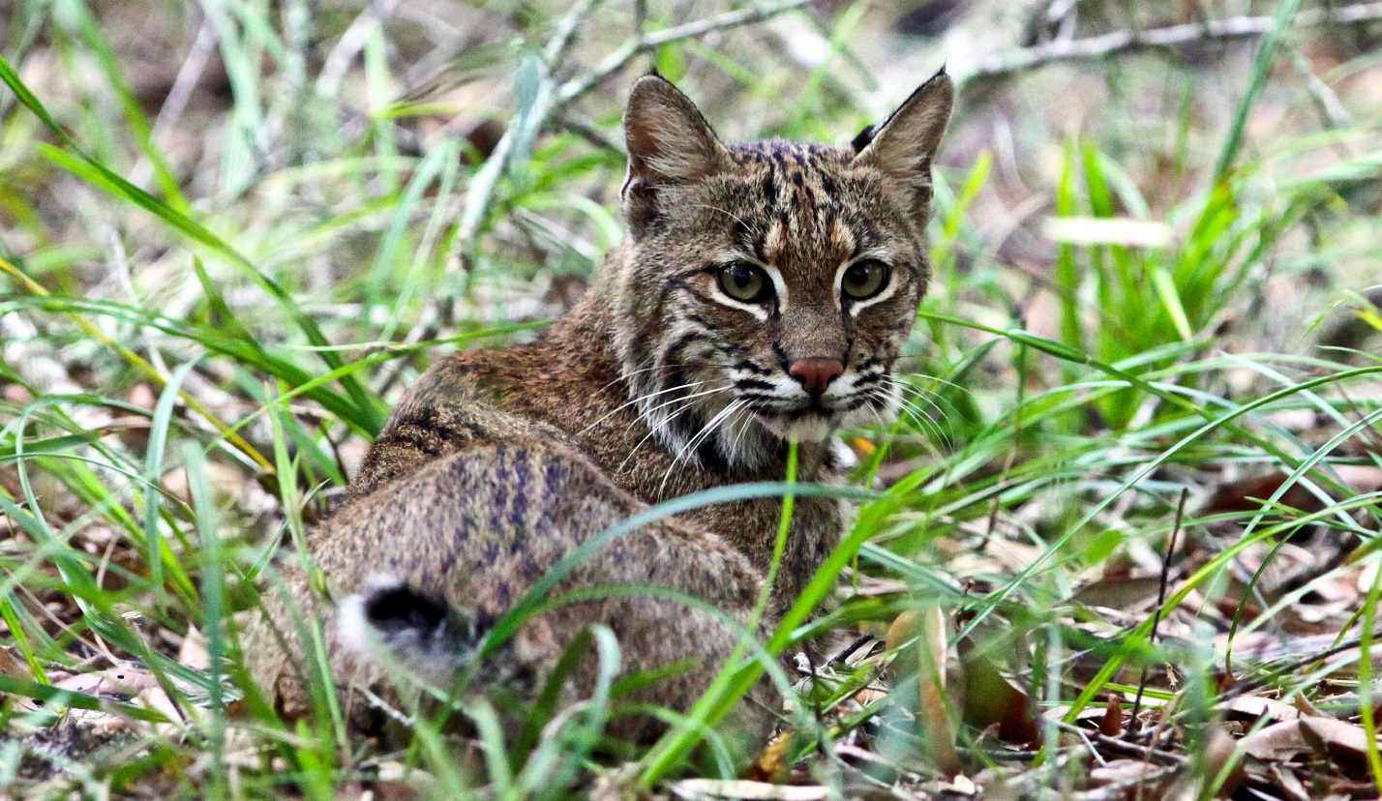

Photo By: Craig O’Neal

**TRACKS**

