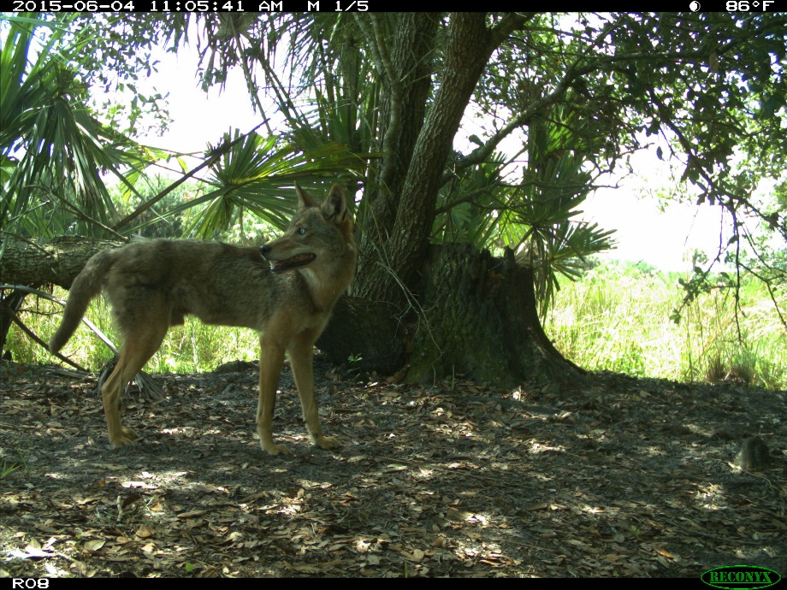
(Needs to be cropped)
Photo By: UF-IFAS

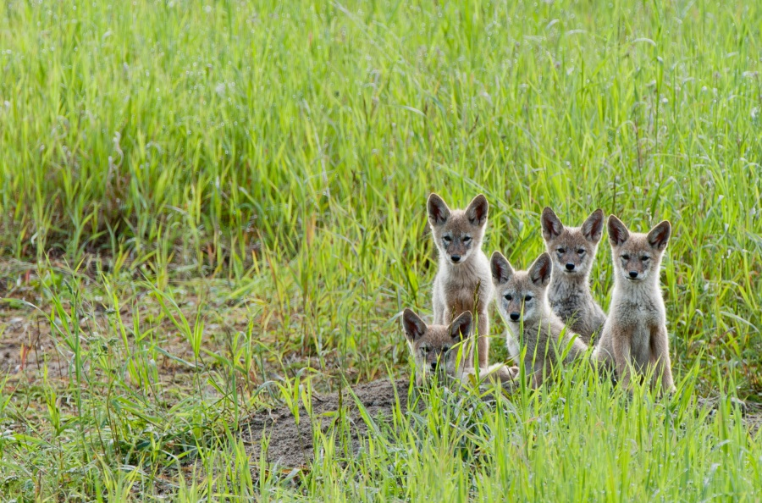
Photo By: Larry Citra
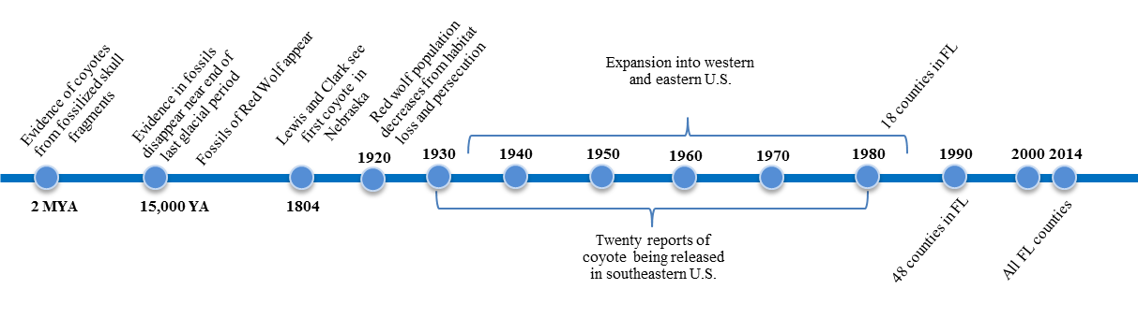
New timeline image created by IFAS graphics design to be edited. 15,000 YA should read “Evidence in fossils of coyote disappears from eastern North America near end of last glacial period”

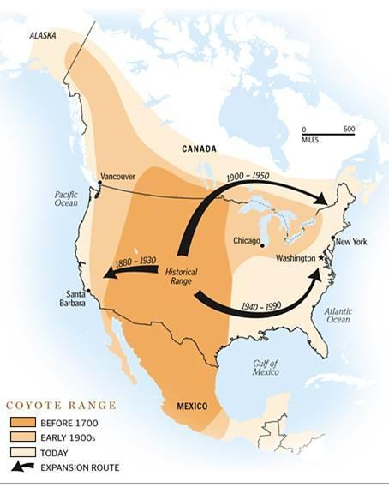
Waiting for permission, Image Courtesy of the Urban Coyote Research Project
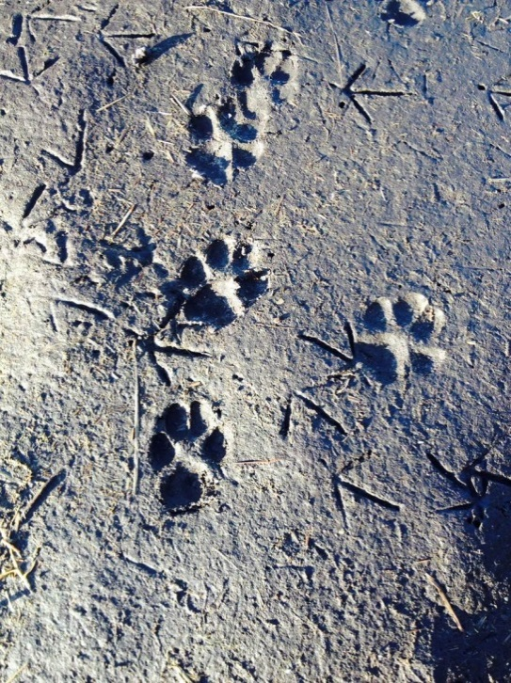
Photo By: UF-IFAS
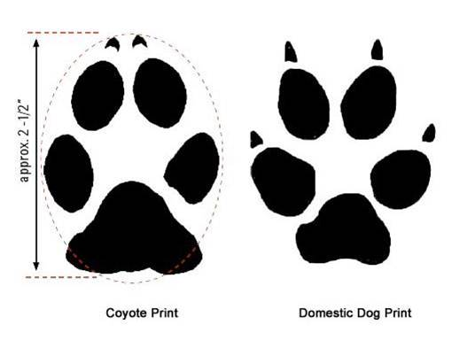
Waiting for permission, Image Courtesy of the Urban Coyote Research Project
Add larger text under each track, “Coyote” and “Domestic Dog”, as well as 2 ½ in. on left

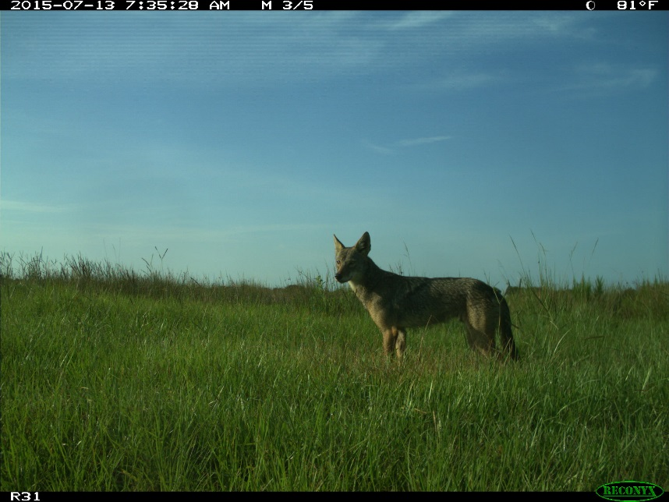
(Needs to be cropped)
Photo By: UF-IFAS
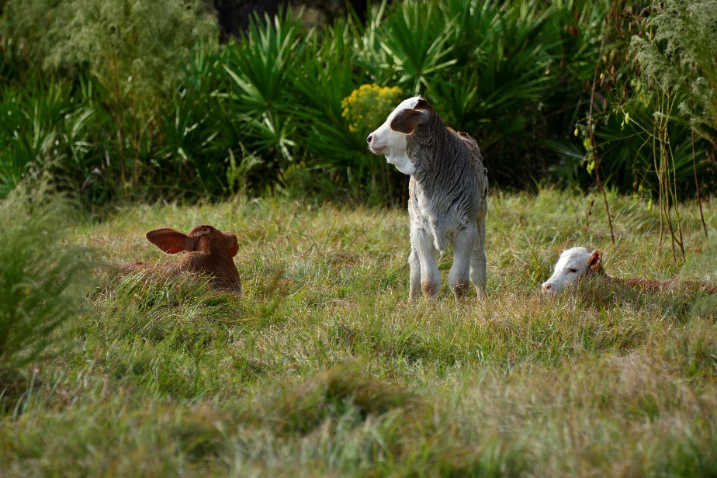
Photo By: Jeff Palmer and Leslie Gaines

