NEED SWINE CARTOON FROM TRACY BRYANT/GRAPHICS DESIGN
Image By: UF-IFAS, Graphics Design

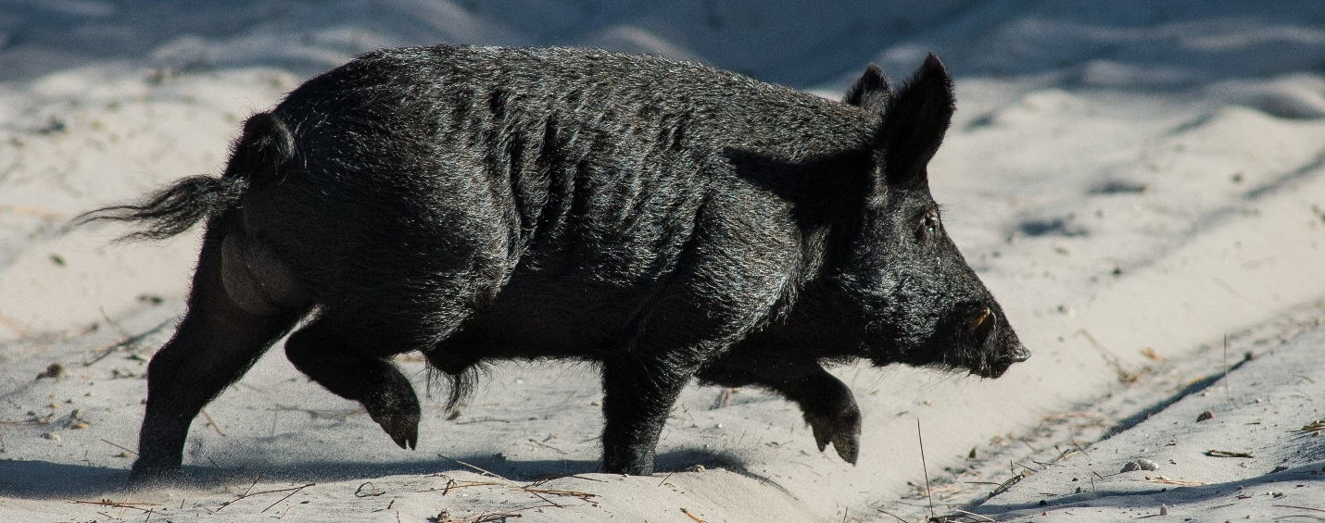
Photo By: Reed Bowman
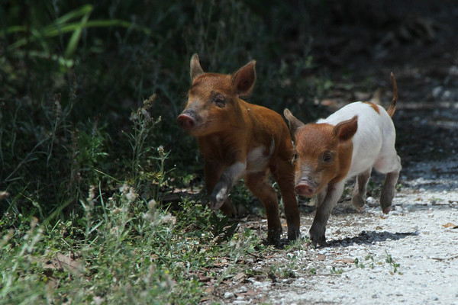
Photo By: Sandy Burford

Distribution of Feral Swine in 2016. (Image Courtsey of Southeastern Cooperative Wildlife Disease Study and USDA)

Tracks
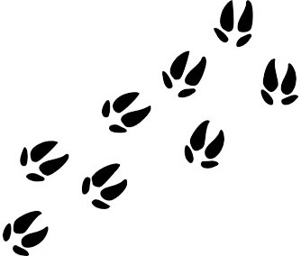

Signs of Feral Swine (Photos By: UF-IFAS)
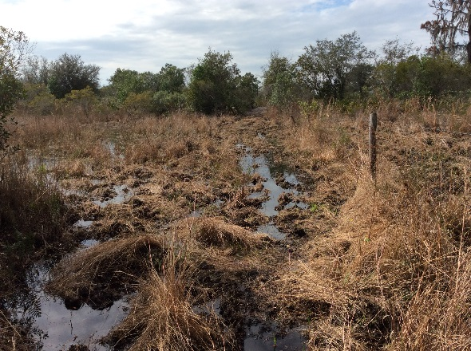
Rooting is common along edges of wetlands
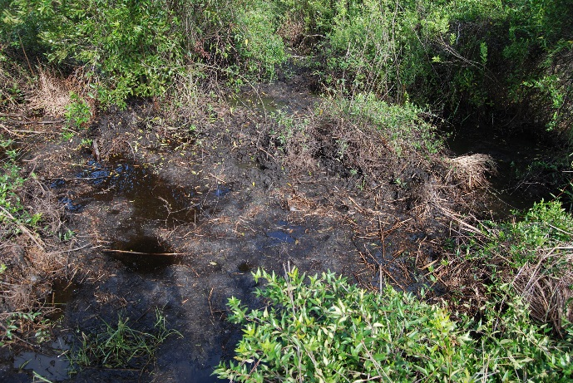
Wallows are often used in shady sites
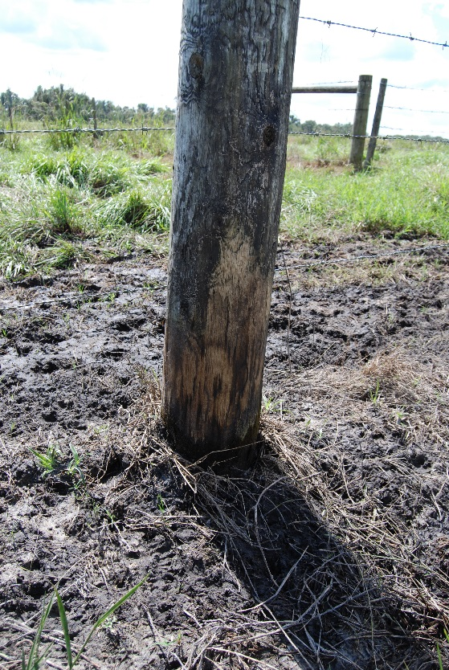
Rubs on posts & trees are likely used as scent marks
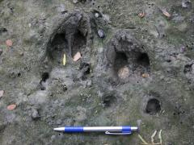
Swine tracks can be identified
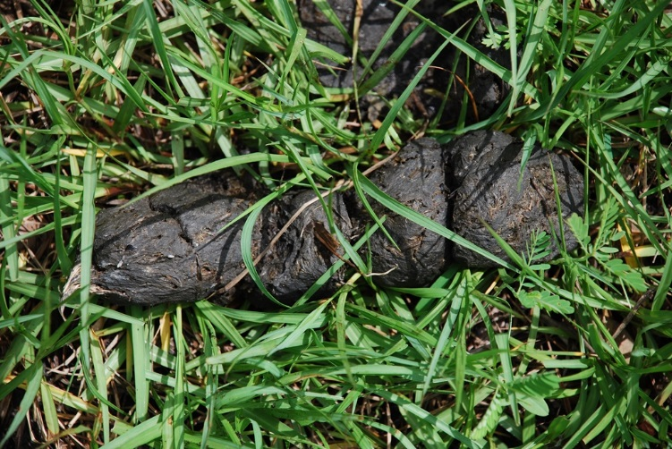
Swine feces vary in size and color depending on local diet

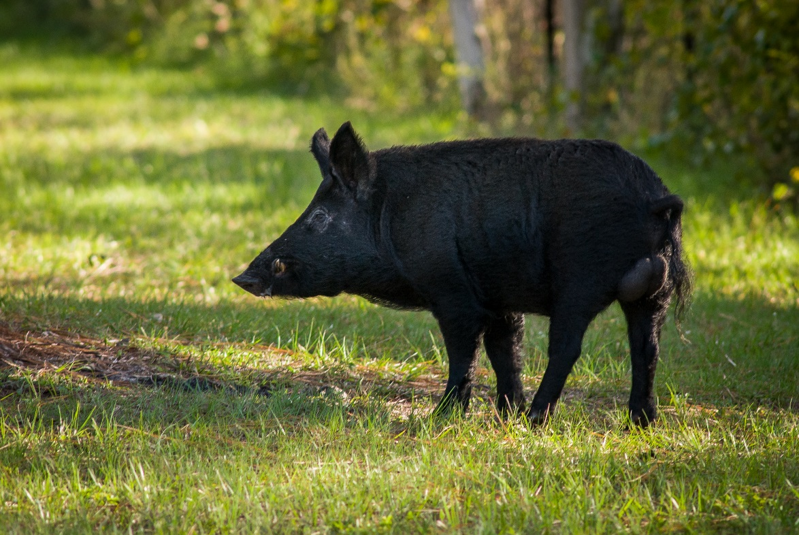
Photo By: Reed Bowman
(Replaces last picture with boar and large tusks)

