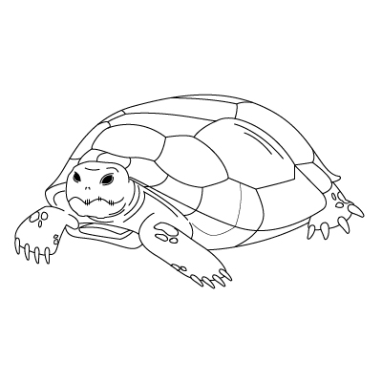
Image By: UF-IFAS Graphics Design

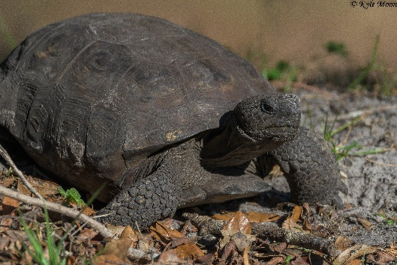
Photo By: Kyle Moon
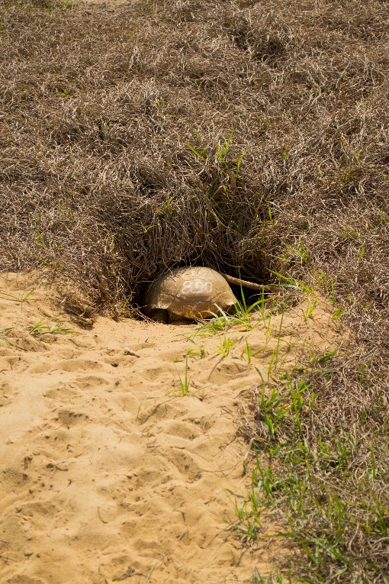
Photo By: Rebecca Tucker
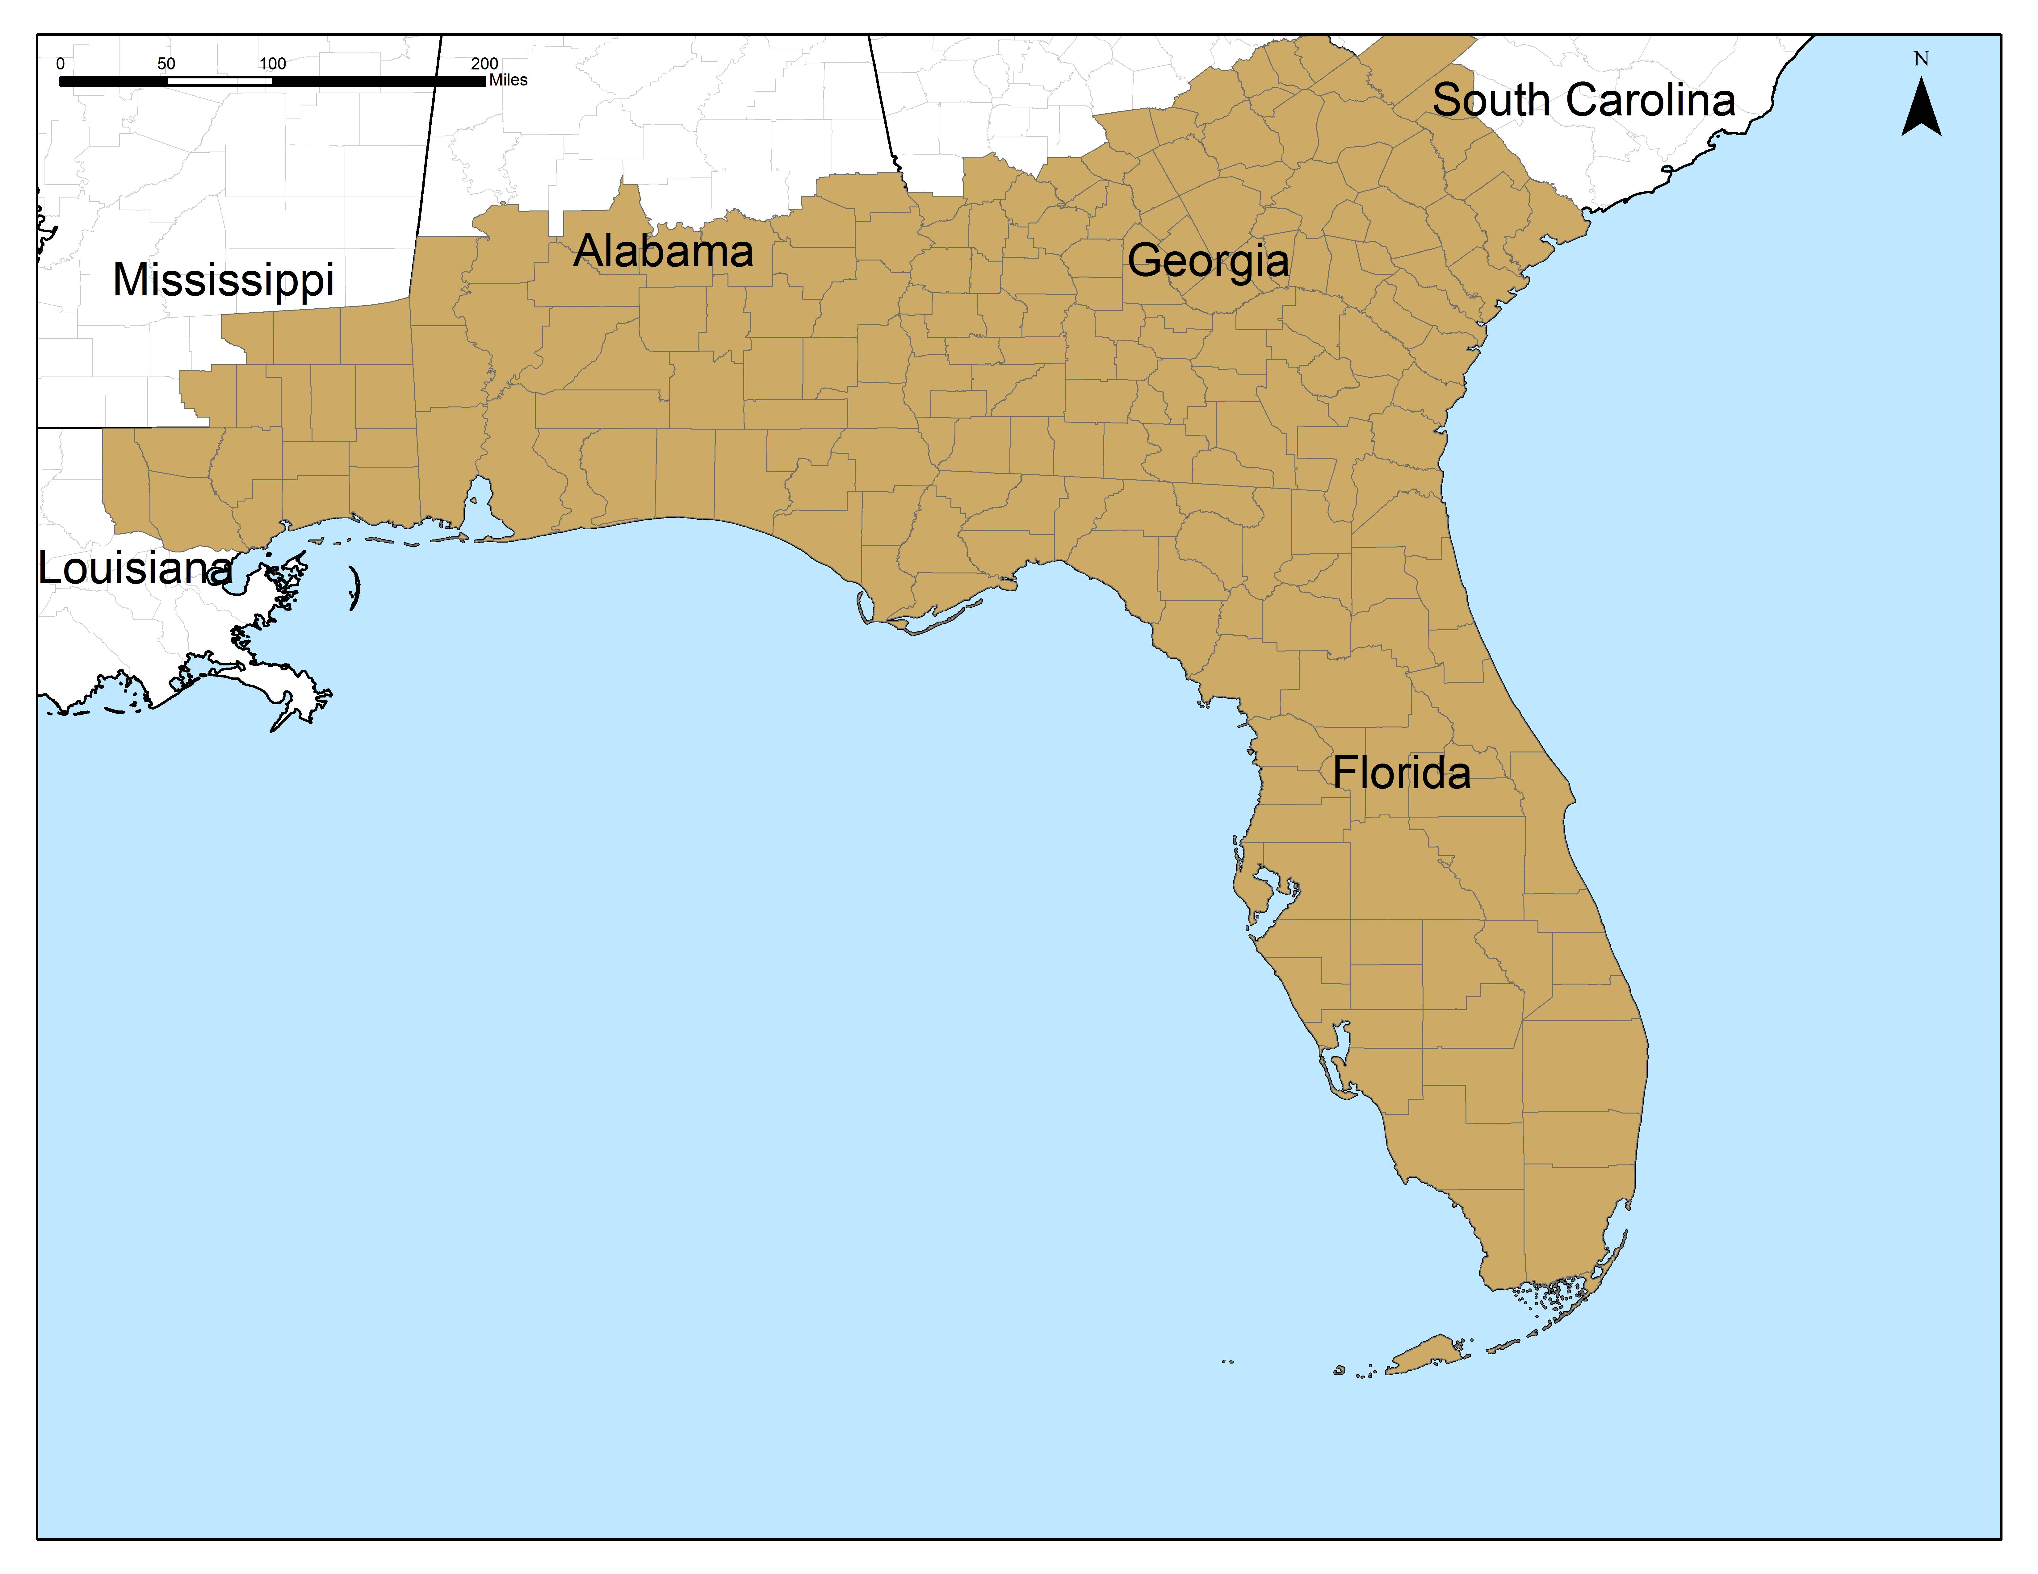
Image By: UF-IFAS, Bethany Wight

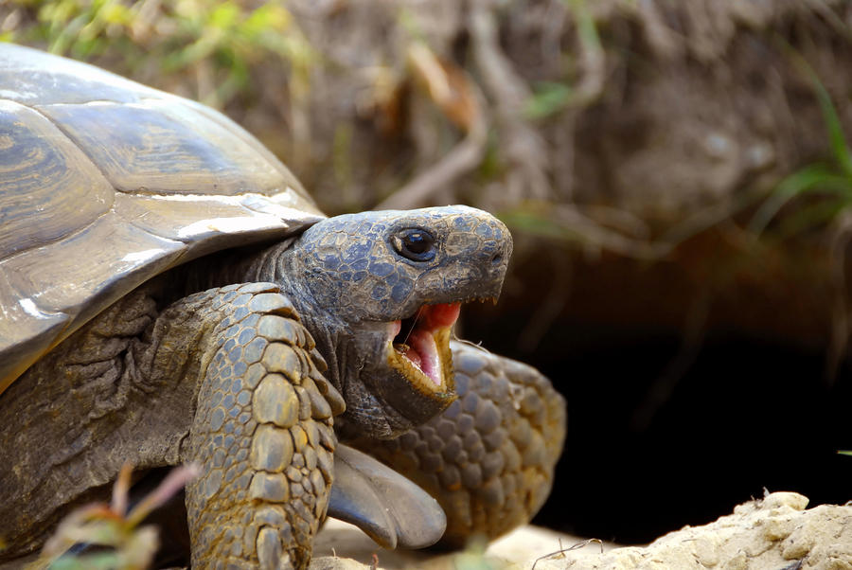
Photo By: Rebecca Tucker

Tracks
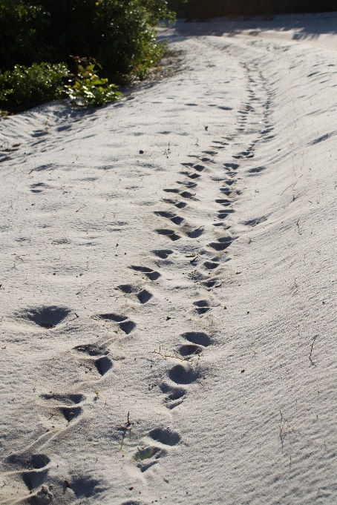
Photo By: Rebecca Tucker

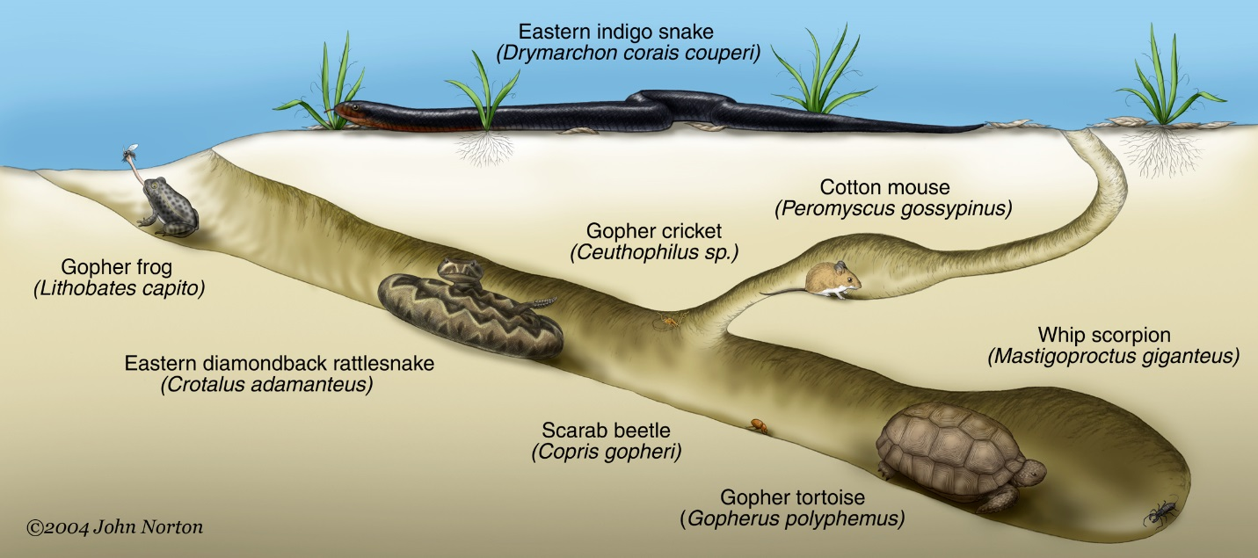
Examples of other wildlife (called commensals) that utilize gopher tortoise burrows.

