Bethany Wight and Raoul Boughton
GOPHER TORTOISE

#005 Rangeland Wildlife Factsheet Series
Breeding
SPRING
SUMMER
FALL
WINTER
Habitat
GRASSLAND OAK HAMMOCK
WETLAND FLATWOODS
SCRUB

Florida’s Keystone Species

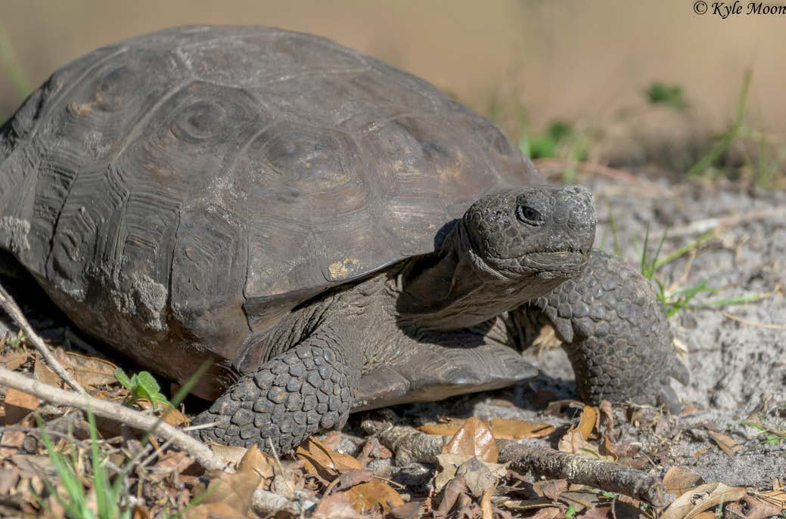SCIENTIFIC NAME: Gopherus polyphemus
PHOTO BY: KYLE MOON
Status
THREATENED
CONCERN
INVASIVE

MIGRATORY

ENDANGERED
COMMON NAME: Gopher Tortoise
HABITAT: Well-drained sandy areas with little canopy and abundant low-growing vegetation.
PHYSICAL DESCRIPTION: Terrestrial tortoise, adults typically 10-15 inches long with an oblong brown or gray shell. Short but strong elephant-like back legs and shovel- like front legs to help dig.
WEIGHT: 8-15 lbs.
DEMOGRAPHIC RATE: Clutch sizes range from 3-15 eggs with an average clutch size of 5-8. Eggs hatch after 80- 100 days depending on temperature.
LIFESPAN: 40-80 years and possibly older in the wild, up to 100 years in captivity.
DISPERSAL: Although gopher tortoises are capable of moving long distances (> 1 km), they are generally quite sedentary and little is known about their dispersal. Home range varies with habitat, season and sex of tortoise but studies have reported annual average home ranges of 0.5- 46 hectares for males and 0.1-5.6 hectares for females.

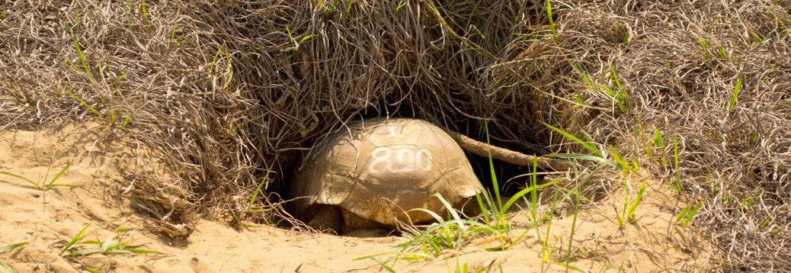BIOLOGY AND BEHAVIOR: Gopher tortoises live in long burrows they excavate that are an average of 15 feet long and 6.5 feet deep. Each burrow has a single entrance, as wide as the length of the tortoise, which provides shelter from weather, fire, and predators. Burrows are typically easy to spot due to the sandy “apron” or mound at the entrance. Gopher tortoises are herbivores feeding on low- growing vegetation such grasses and legumes, and other herbaceous plants. They get most of their water from plants and rarely seek out water to drink, usually only in
PHOTO BY: REBECCA TUCKER
a drought. These tortoises do not reach sexual maturity until about 10-15 years depending on resources. During the breeding season, males visit female burrows within a colony and court the resident females through shell nipping, head bobbing and rubbing pheromones from scent glands on their legs. Females lay a single clutch of
eggs annually in the sand mound at the burrow entrance or in another open, sunny spot. Nest and hatchling predation is high and females may only have a successful nest every 10 years. .

Did you know?
Gopher tortoises are a keystone species, meaning other animals depend on them for survival. The burrows created by gopher tortoises are used by more than 350 other species, called commensals, including the burrowing owl, Florida mouse, gopher frog and eastern indigo snake.

UF/IFAS - Department of Wildlife Ecology & Conservation - Range Cattle Research and Education Center - Rangeland Wildlife & Ecosystem Program - Ona, FL

GOPHER TORTOISE
FAST FACTS
- Gopher tortoises feed on a variety of plants and also spread and
fertilize seeds through their dung.
- Gopher tortoises cannot swim! Never relocate a tortoise to water.
- The longest recorded gopher tortoise burrow was over 47 feet long!

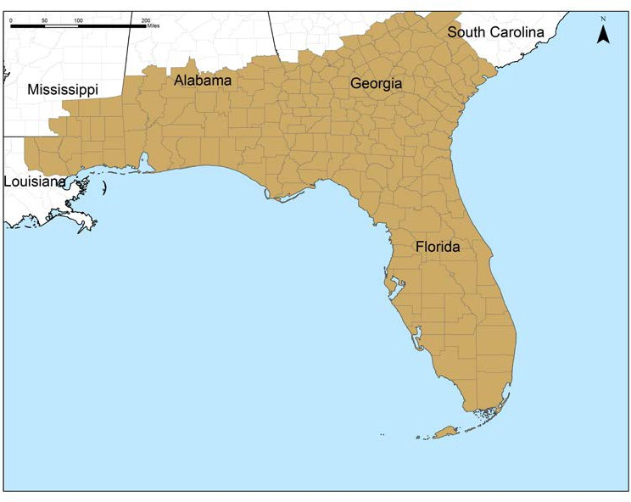
States and counties with Gopher Tortoise populations.

HISTORY & DISTRIBUTION:
Gopher tortoises descended from a species of land tortoise that occupied western North America about 60 million years ago. Today only five tortoise species remain and the gopher
THREATS: Habitat loss resulting from human development poses the greatest risk to gopher tortoises through conversion and fragmentation of tortoise habitat. The resulting fragmented landscape reduces habitat, inhibits beneficial management with prescribed fire, disrupts dispersal of tortoises among populations, and increases the potential for negative interactions with humans, pet species (i.e., dogs), and vehicles. Gopher tortoises living
on proposed development sites may be relocated to a new area (with proper permits; Contact your local FWC office), however, relocations are often unsuccessful as the tortoises rarely stay at their new site, may spread
disease, and may disrupt resident tortoise populations.

tortoise is the only one that occurs east of the Mississippi
River. Human activities and loss of habitat have eliminated the gopher tortoise from parts of its historic range in North Carolina, northern Alabama, western Louisiana and eastern Texas.

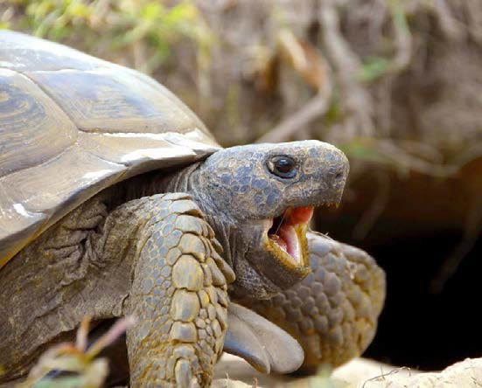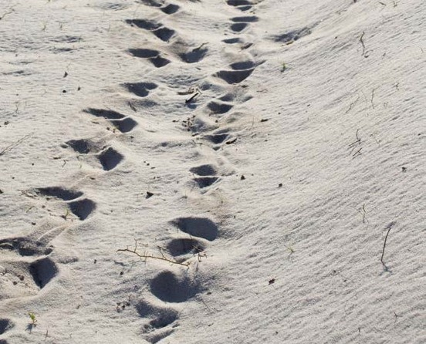 TO LEARN MORE
Tracks
PHOTO BY: REBECCA TUCKER
PHOTO BY: REBECCA TUCKER
- Gopher Tortoise Council: http://www.gophertortoise council.org/about-the-tortoise/
- Pine Ecosystem Handbook for Gopher Tortoises: https://www.fws.gov/endangered/esa-library/pdf/ Handbook_Gopher_Tortoise.pdf

FWC: http://myfwc.com/GopherTortoise
Several management plans by the Florida Fish and Wildlife Conservation Commission (FWC) and USDA’s Natural Resource Conservation Service (NRCS) are being implemented to restore and maintain gopher tortoise habitat and populations.

HOW YOU CAN HELP
- Grow native gopher tortoise friendly plants on your property such as wiregrass, broadleaf grasses, wild peas, blueberries, and prickly pear.
- State law protects gopher tortoises and their burrows. Only permitted individuals are allowed to relocate them. Please do not harass, pursue or molest them.
- Avoid mowing, driving over or disturbing the area around a burrow and never block a burrow opening.
- Report gopher tortoise locations using this App, http://myfwc.com/wildlifehabitats/managed/gopher-tortoise/app/.
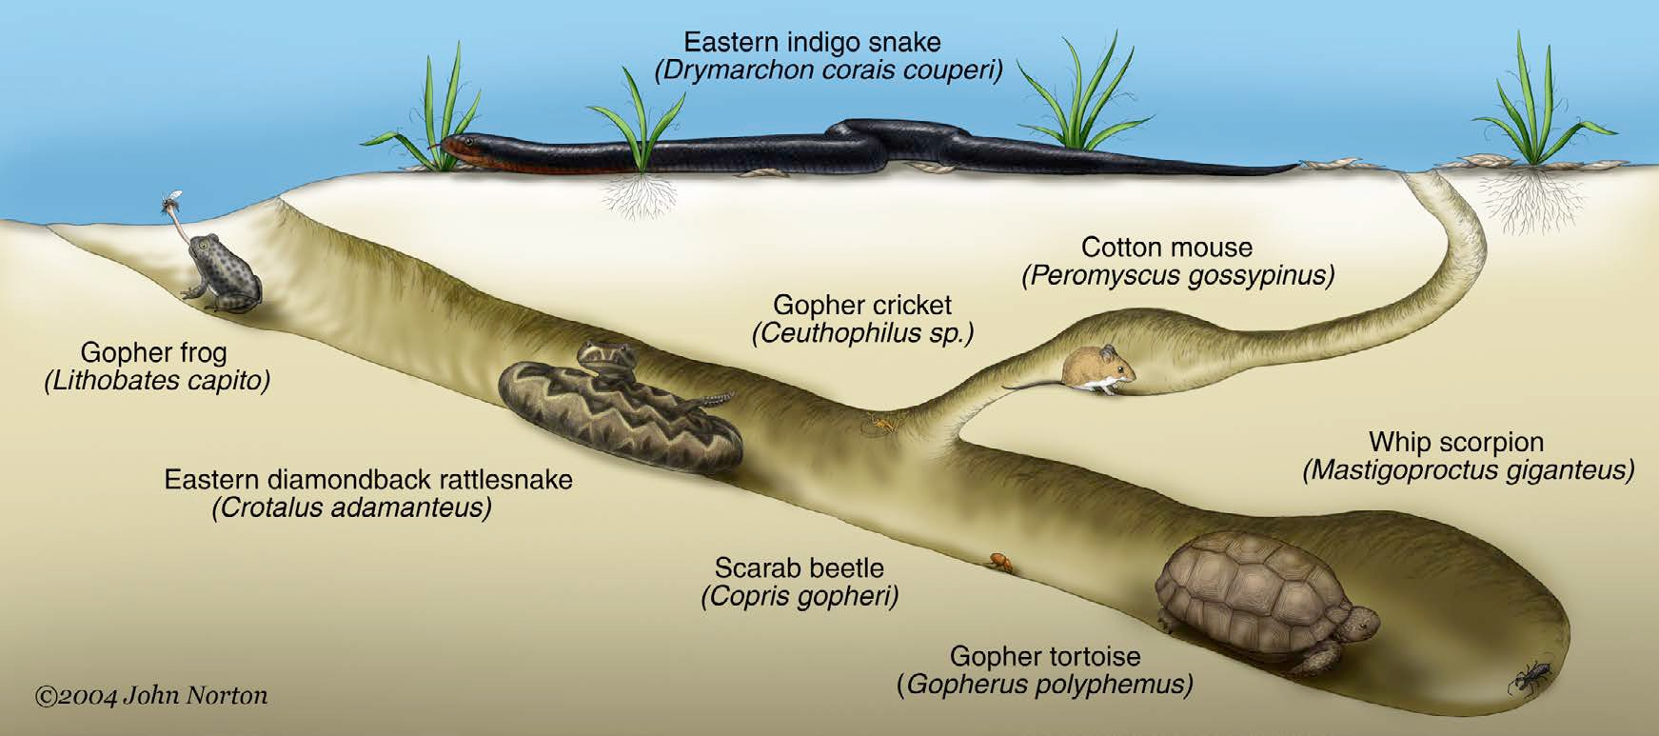
Commensals, examples of other wildlife that utilizes gopher tortoise burrows.

An Equal Opportunity Institution. UF/IFAS Extension, University of Florida, Institute of Food and Agricultural Sciences, Nick T. Place, dean for UF/IFAS Extension. Single copies of UF/IFAS Extension publications (excluding 4-H and youth publications) are available free to Florida residents from county UF/IFAS Extension offices.

