Publication #FCS8568
Healthy Eating: Calcium
Linda B. Bobroff²

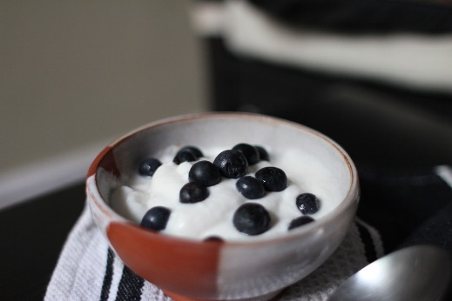
Figure 1. Yogurt is a great source of calcium.

https://pixabay.com/p-763372/?no_redirect

CC0 Creative Commons
Free for commercial use
No attribution required

Figure 2. This dish contains three sources of calcium: tofu, kale, and black beans.
Credit:
Photo by Nora Kuby. Used here under Creative Commons license CC BY-NC-SA 2.0. Source: http://flic.kr/p/6Dd3M8.

