Facts about Iron FCS8704 FY217

Photos



Figure 1. When your body does not have enough iron you may feel tired and have problems concentrating on tasks

iStock ID: 484188877

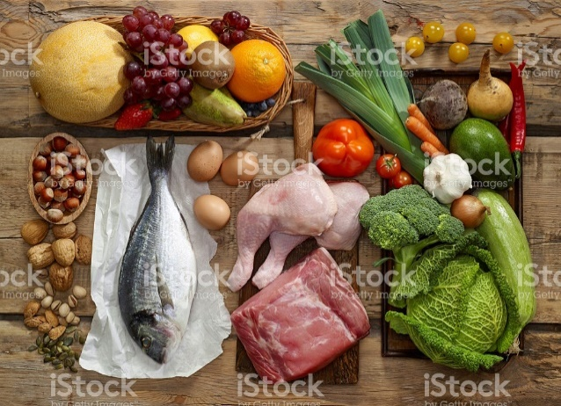

Figure 2. Meat, poultry, and fish are naturally rich sources of iron. The form of iron in these foods is well absorbed.

iStock ID: 537854283

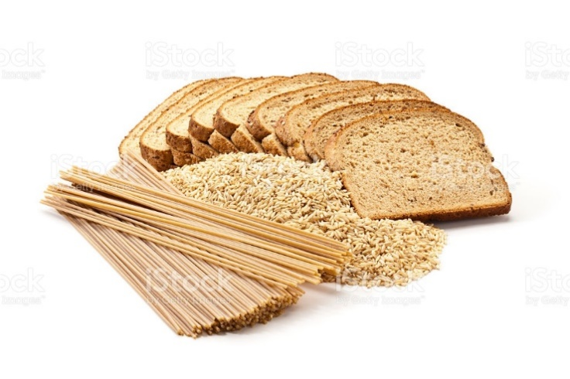

Figure 3. Whole grain foods are fortified with iron. To increase absorption of this form of iron, eat these foods with a source of vitamin C, like orange juice, cantaloupe, or bell peppers.

iStock ID: 578577836