FCS8634
Food Safety: Five Steps to Food Safety

Image – no change from last version

Figure 1. Food Safety Basics

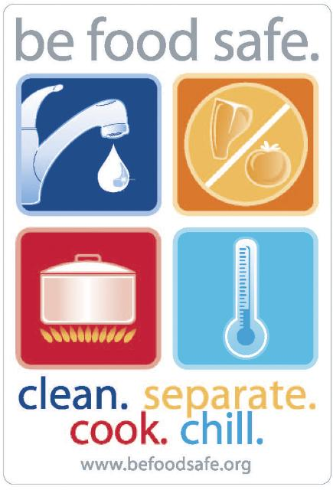

Credit: http://www.befoodsafe.org

