

**Figure 1.** Healthy soils with high organic matter will equate to higher water holding capacity. (Credits: Jehangir Bhadha).

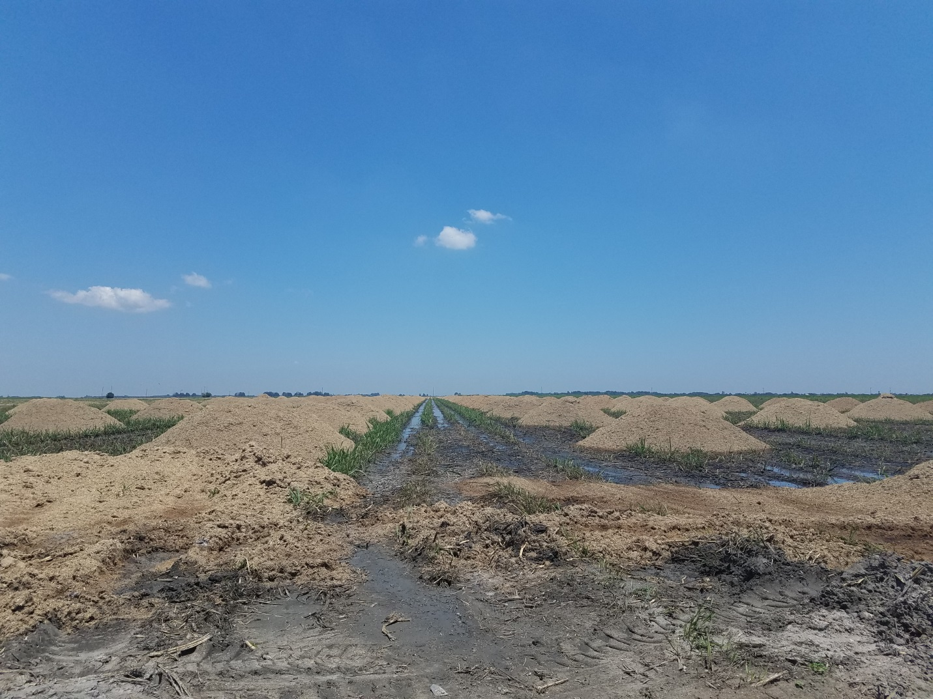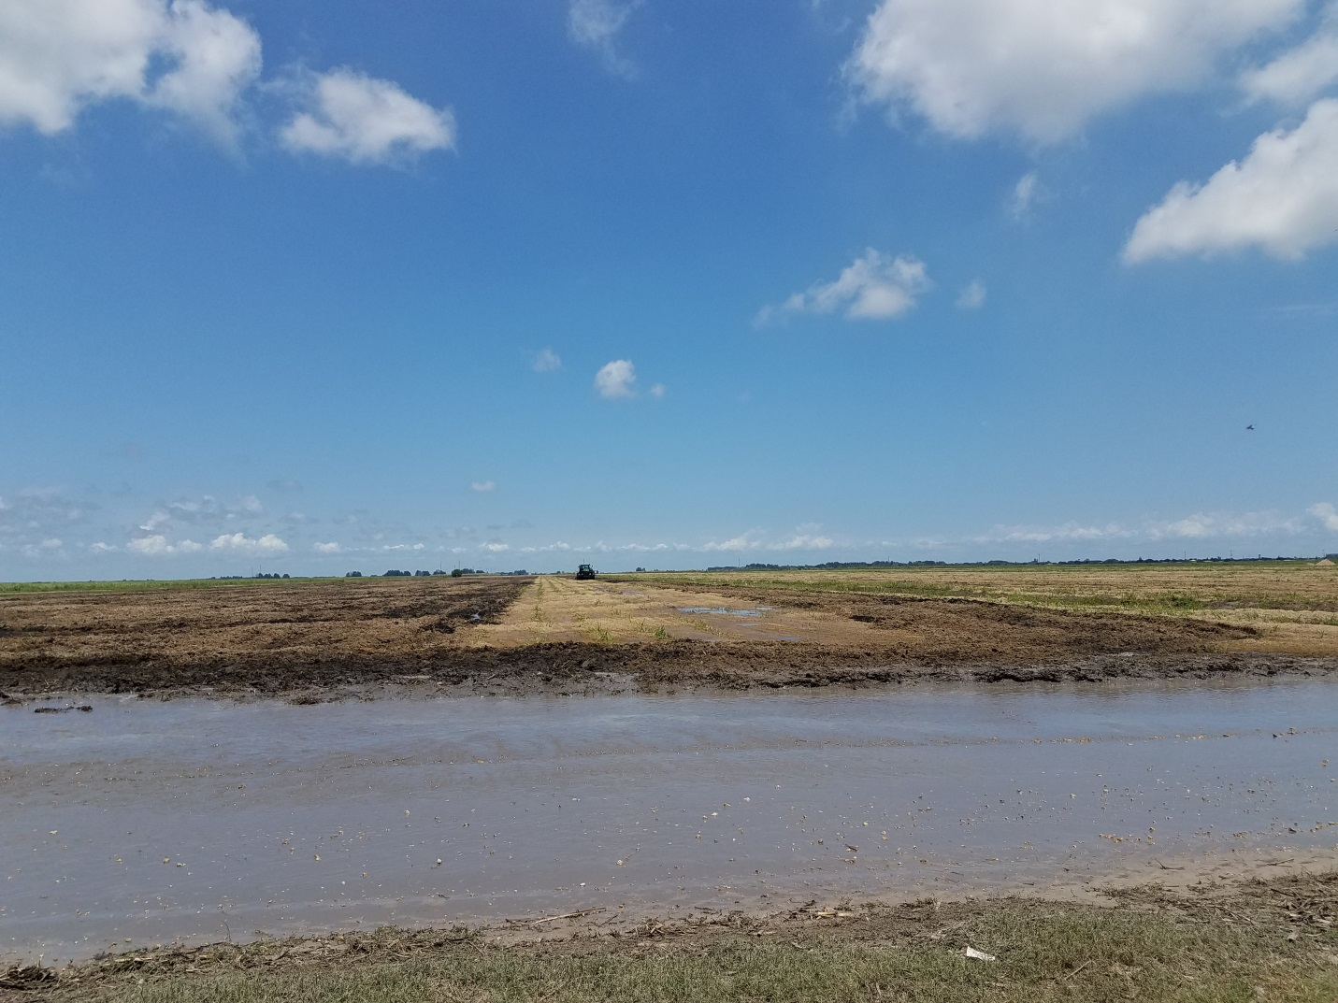

**Figure 2.** Bagasse being applied as organic soil amendment on sandy soils in South Florida. (Credits: Raju Khatiwada and Stewart Swanson).

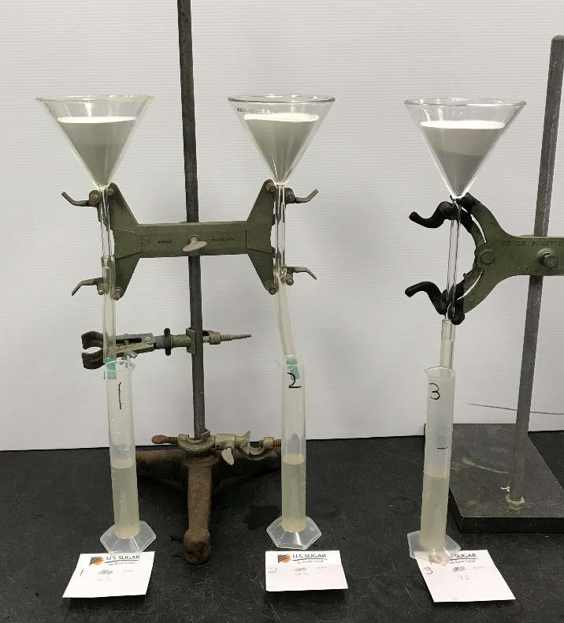

**Figure 3.** Laboratory experimental setup for measuring maximum water holding capacity. (Credits: Jay Capasso).



**Figure 4.** Changes in maximum water holding capacity of sand and limerock with percent increase in soil OM.