Publication #FCS8750
Healthy Meal Plans
Linda B. Bobroff

Getty Images (except Figure 1, which is from USDA)
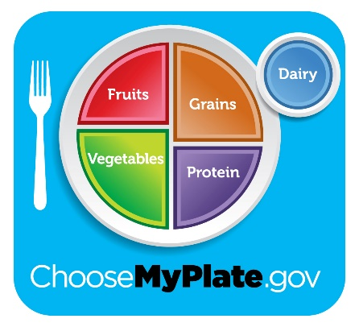
Figure 1. MyPlate can help you plan healthy meals. Visit ChooseMyPlate.gov for tips on making healthy food choices and resources to help you keep track of your food intake and physical activity.

http://www.gettyimages.com/license/518337947
Figure 2. Be sure to choose foods you enjoy! It will help you stick with your meal plan.

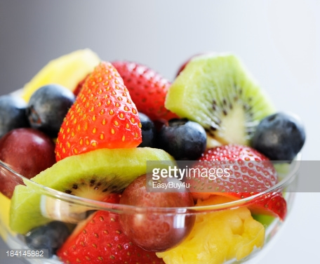
http://www.gettyimages.com/license/184145882
Figure 3. Fruits provide only 60 calories in one serving, along with vitamins, minerals, and fiber. They are naturally sweet and make great snacks or desserts.

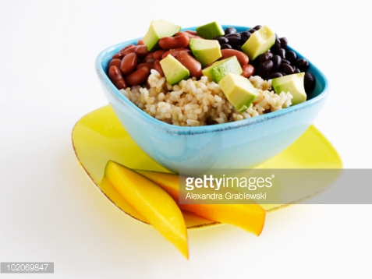
http://www.gettyimages.com/license/102069847

Figure 4. Vary your protein sources! Eat legumes or fish several times each week in place of meat or poultry. This vegetarian dish has black and red beans, rice, and avocado, a great source of healthy fat.

